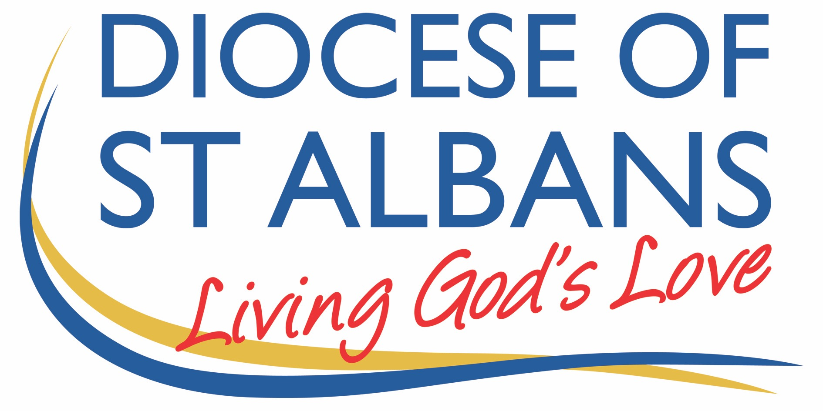

Sunday 26th September 2021 – Trinity 17

Mark 9.38-end

Welcome to Praying Together

Gathering Before God

Make sure you are sitting comfortably.
I am in the presence of the Living God, Father, and of the Son, and of the Holy Spirit. Amen.

Prayer of the Day:

Almighty God,
you have made us for yourself,
and our hearts are restless till they find their rest in you:
pour your love into our hearts and draw us to yourself,
and so bring us at last to your heavenly city
where we shall see you face to face;
through Jesus Christ your Son our Lord,
who is alive and reigns with you,
in the unity of the Holy Spirit,
one God, now and for ever Amen.

Reflection

Breathe slowly and deeply.
Ask God to speak to you through the passage that you are about to read.

Bible Reading: Mark 9.38-end

John said to him, “Teacher, we saw someone casting out demons in your name, and we tried to stop him because he was not following us.” But Jesus said, “Do not stop him, because no one who does a miracle in my name will be able soon afterward to say anything bad about me. For whoever is not against us is for us. For I tell you the truth,
whoever gives you a cup of water because you bear Christ’s name will never lose his reward. “If anyone causes one of these little ones who believe in me to sin, it would be better for him to have a huge millstone tied around his neck and to be thrown into the sea. If your hand causes you to sin, cut it off! It is better for you to enter into life crippled than to have two hands and go into hell, to the unquenchable fire. If your foot causes you to sin, cut it off! It is better to enter life lame than to have two feet and be thrown into hell. If your eye causes you to sin, tear it out! It is better to enter into the kingdom of God with one eye than to have two eyes and be thrown into hell, where their worm never dies and the fire is never quenched. Everyone will be salted with fire.
Salt is good, but if it loses its saltiness, how can you make it salty again?
Have salt in yourselves and be at peace with each other.”

Some thoughts for further Reflection:
Mark records this short saying of Jesus.
Salt is good, but if it loses its saltiness, how can you make it salty again? Have salt in yourselves and be at peace with each other.”
It is a saying that has a similar expression in Mathew’s and Luke’s Gospel. (Mt5:13,Lk:14:34-35)

The words of Jesus in Mark can be seen to have in the first part a reference to fire and in the second part a reference to the effectivity of salt.
This small saying of Jesus has a magnitude of importance that far out runs the words and the images of the saying.
The reference to fire can be understood on the surface as a reference to the way fire is used in the temple in the purification of the sacrifices or in the purification by fire of raw material like gold and silver. Such direct reference of fire with purification is clearly seen in 1 Peter 1:7.

For Mark the reference to fire may well be on the one hand to the purification of life through the fire of God’s Word. Something similar is found in the words of John the Baptist when he says, ‘The one who will come after me will baptise you with Holy Spirit and fire.’ (Mt3:11)
On the other hand, for Mark and those with whom he is speaking, the words of Jesus could also be a reference to the opposition and persecution of the disciples’ life because of their life with Christ. Clearly purification and persecution can often be seen and understood as part of the same experience in the disciples’ life.
Mark now links the properties of fire with the properties of salt. Again, on the surface we could simply note the way in which salt, fire and sacrifice are linked in the cultic worship of the temple.

Another point of entry would be to focus on the salt itself. The reference to the life of the disciple as salt is picked up in other places in the gospels. (Mt5:13,Lk:14:34-35)
In Mark’s the analogy with the disciples’ life as salt, what is unique is that the disciples’ life is tested through purification and persecution.

Mark, like Mathew and Luke speaks about how the quality, the essence, of salt can be lost.
For the early disciples and for us there is the realisation that there is nothing guaranteed or as a matter of assumption about God’s favour in our lives.
It is because we cannot make any assumptions or demands that Paul says we need to work out our faith with fear and trembling. (Phil 2:12).
The assumptions of the people was often that as the children of Abraham they were always guaranteed the favour of God and it was something that Jesus continually had to question and often overturn so that the eye and ear of the heart could hear the gospel.

The reference to salt and the possibility of losing it begs two questions which we might be able to search out with gentleness of our soul.
What does it mean for my life with Christ to be as salt?
What might I need to do with Christ to maintain its saltiness and to avoid becoming saltless, something which adds no good taste to the world?

OUR PRAYERS

O Christ you are my light, a light to guide me,
A love to surround me,
Grant me, so to desire your love,
That I recognise your light,
Within me, today and always.
I who desire to be the salt of your being on the earth.
Lord in your mercy, answer my prayer

My Christ I pray for an end to injustice, violence and fear in my world, your world.
May governments and leaders work tirelessly for peace and equality so that all people can enjoy the life you would have for them, life in its fullness.
Lord in your mercy, answer my prayer

O Christ all life comes from you and is held and sustained by the breath of your Spirit.
For all who are sick and needy at this time I pray.
For those close to me and those far way.
Grant to those who long for health the knowledge of your kindness
and the warmth of your Spirit and healing.
Lord in your mercy, answer my prayer.

For all whose gift of life and living has ended in death.
For all whose living is renewed and revealed on a more distant shore I pray.
Grant them with me the gift of peace and light this day.
You who are the giver of the starry night,
The one who has said I am with you always, even till the end of time,
who love for me is perfect and without fear.
Lord in your mercy, answer my prayer,

May the flame of your love
burn brightly through me, a path to others.
To all who are seeking to return you,
But don’t know how,
May your will be done, as it is in heaven.
Lord in your mercy, answer my prayer.

An act of spiritual Communion

My Jesus,
I believe that You
are present in the Most Holy Sacrament.
I love You above all things,
and I desire to receive You into my soul.
Since I cannot at this moment
receive You sacramentally,
come at least spiritually into my heart.
I embrace You as if You were already there and unite myself wholly to You.
Never permit me to be separated from You. Amen.

The Lord’s Prayer

Our Father, who art in heaven, hallowed be thy name;
thy kingdom come; thy will be done;
on earth as it is in heaven.
Give us this day our daily bread.
And forgive us our trespasses,
as we forgive those who trespass against us.
And lead us not into temptation; but deliver us from evil.
For thine is the kingdom,
the power and the glory, for ever and ever. Amen.

To keep up to date with resources and dates from the Flourishing Churches team, please follow us on Facebook: https://www.facebook.com/Flourishing-Churches-St-Albans-Diocese-105528844479183
Also St Albans Diocese Youth Service: https://www.facebook.com/stalbansdys/
And Children’s Ministry St Albans Diocese: https://www.facebook.com/stalbanscme

