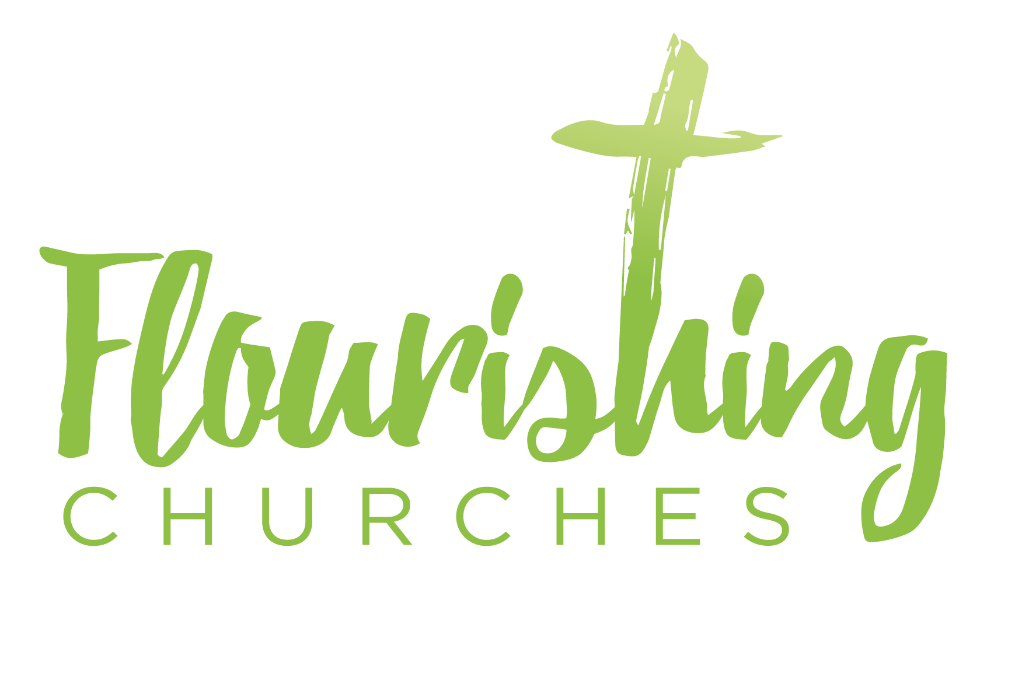
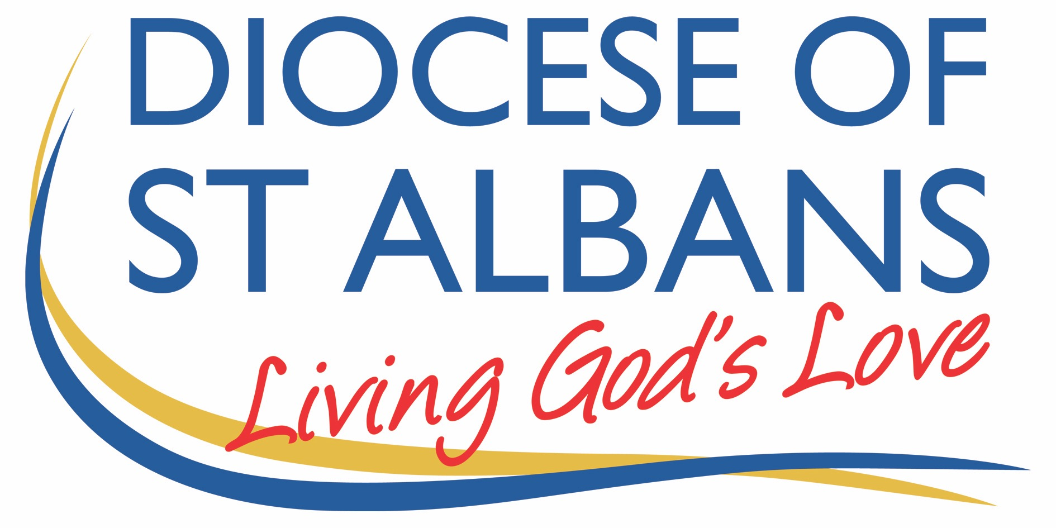

Sunday 12th September 2021 – Trinity 15

Mark 8 v27-end

Welcome to Praying Together

Hymn Suggestions
Alleluia! Sing to Jesus
Take my Life
Come my Way
Take up Thy Cross
Will you come and follow and me
I will offer up my life
Hail to the Lord’s Anointed

There are also hymns here from St Martin’s in the Field: https://www.achurchnearyou.com/hub/asset/hymns-and-choral-music

Prayer of the Day:
Lord God,
defend your Church from all false teaching
and give to your people knowledge of your truth,
that we may enjoy eternal life
in Jesus Christ our Lord. Amen.

Preparation

Give everyone a cross made from red material or crépe paper. Tell them it is red because Jesus gave his life that we may have life eternal. Ask everyone to hold their cross and think of something that is really bothering them. Ask them to bring their trouble to Jesus Christ. As an outward sign we will come to the front of the church one by one and place the red crosses in a bowl. They could do this during the first hymn.

Reflection
Breathe slowly and deeply.
Ask God to speak to you through the passage that you are about to read.

Bible Reading: Mark 8 v27-end

Jesus went on with his disciples to the villages of Caesarea Philippi; and on the way he asked his disciples, ‘Who do people say that I am?’ And they answered him, ‘John the Baptist; and others, Elijah; and still others, one of the prophets.’ He asked them, ‘But who do you say that I am?’ Peter answered him, ‘You are the Messiah.’ And he sternly ordered them not to tell anyone about him.
Then he began to teach them that the Son of Man must undergo great suffering, and be rejected by the elders, the chief priests, and the scribes, and be killed, and after three days rise again. He said all this quite openly. And Peter took him aside and began to rebuke him. But turning and looking at his disciples, he rebuked Peter and said, ‘Get behind me, Satan! For you are setting your mind not on divine things but on human things.’
He called the crowd with his disciples, and said to them, ‘If any want to become my followers, let them deny themselves and take up their cross and follow me. For those who want to save their life will lose it, and those who lose their life for my sake, and for the sake of the gospel, will save it. For what will it profit them to gain the whole world and forfeit their life? Indeed, what can they give in return for their life? Those who are ashamed of me and of my words in this adulterous and sinful generation, of them the Son of Man will also be ashamed when he comes in the glory of his Father with the holy angels.’

Some thoughts for further Reflection:

The Gospel reading today has a number of questions explicitly asked, and some answers too. However, there are more implicit questions that are very hard to answer:
- What does it look like to say ‘No’ to yourself and ‘Yes’ to God?
- What would it look like to completely lay aside our own agendas and to instead live for God?
- Is that even possible? It might be for saints and those with a special calling, but what if we are ordinary people with jobs and families and bills to pay?
- And if it is possible, why would you want to do that, live completely for God?
- What is the cost involved in doing that?
- How much needs to change?

But let’s leave those questions for now and take a look at what prompted Jesus to tell a crowd that gathered around him that if they want to follow him it requires that every day they take an instrument of humiliation, torture, and death, and carry it the places that they are asked to go.

Confession of Jesus’ Messiah status

Peter has just confessed that Jesus is the Messiah. ‘The penny has dropped’. This event, the arrival of God’s Messiah, that he has been waiting for all his life has finally happened: and not just happened, but happened in front of him, and not just happened in front of him, but he is an active part of it.

Peter learnt to read and write at the synagogue, studying the Hebrew Scriptures, what we call the Old Testament. And at some pint he was told that he had done well, but that he did not show the promise of being a scholar, an expert in the Law – few did, and so he should go and learn his father’s trade. At about the age of 13 or 14 Peter learnt how to fish, his hands grew calloused, he smelt of dirty water when he cleaned the nets each day, he talked in the common peasant language, he was a straight forward, ordinary person – that is until some Rabbi had come along one day and asked him to be his disciple.

Peter was too old, at about 20 years of age; he had already shown that he couldn’t learn what you needed to learn in order to be the student of a Rabbi. Peter should have said no, but he had to say yes. He followed Jesus, and now Peter has come to the realisation that this Jesus is the Messiah!

After Peter makes his confession and realises who Jesus is, Jesus tells him and the other disciples not to tell anyone. This seems strange – you would think that this would be precisely the thing that should be told to everyone. Jesus tells them why not to tell anyone.

Jesus predicts his passion

Jesus is going to be rejected by the leaders of the nation of Israel, he will be made of fool of, and then he will be killed by the Romans: and all this needs to happen at the right time, in God’s time, so don’t tell anyone about Jesus being the Messiah right now, keep it quite, let things play out in God’s time.

What happens next is that Peter, about 30 seconds after getting it and realising that Jesus is the Messiah, 30 seconds after feeling his world is sorted out, 30 seconds after realising that this best friend in the whole world, his Rabbi is the Messiah the Son of God, moves on to defintely not getting it, to the whole thing being completely ridiculous, insane, stupid, this was not how it was meant to be, what on earth are you talking about?

Peter, I imagine, along with the other disciples, feels sick and angry. ‘Jesus! Don’t be stupid. No way, it will never happen, you’re the Messiah, God will never let that happen. The Scribes and Elders will love you – you’re the Messiah! The Romans won’t kill you! Don’t talk about dying, talk about conquering! That is what God is calling you to do, that is what it is all about!’

If the Messiah Suffers, so will the Disciples.

The issue is that the Messiah didn’t come to affirm the world and say that everything would be ok. The incarnation of Jesus was not about turning up and telling everyone, ‘Well done chaps. You are doing great; keep going for it.’ Jesus came to change things, to conquer sin and death, to tell the world to turn around and go in the right direction.

Maybe what Jesus is saying then is something like: ‘I tell you what this is going to take folks. You are going to die to yourselves and be born again. And then you will likely make a mistake again - so you’ll have to die again. Listen, just carry your cross with you every day, you’ll need it. I know that is tough, but if you really want to follow me that is what it will take. I am going to do the will of my Father, I’m going to heaven, I am going to make creation the way that it should be.’

Carry your cross daily.

And so, we come to the question of what might it look like if we lived for God's purposes and not our own. It would mean carrying our cross daily, but what would that look like?

It is a hard question to answer unless we have some idea of what God's purposes for our lives might be – what is it that God is asking us to do? The answer is that God wants us to be children of God, and God has sent us Christ, God’s Son, to show us what it looks like to live as children of God. You must love your neighbour, not your church building or the institution of your religion. You must preach Good News to the poor, not make the accumulation of worldly wealth your main goal in life. You must welcome to your table those who others have labelled as unclean, and eat with them, not seek to maintain purity and be above it all. In short we must try, each day, to become more like Jesus Christ.

There are many people who have lived like that throughout history, some of the well-known, some of them less so. One was Fannie Lou Hamer, a Civil Rights activist who worked hard on voter registration. She said, ‘I am sick and tired of being sick and tired,’ and did what she could to correct unjust structures of society. She was not happy when people merely claimed to be a Christian but weren’t willing to try to emulate Christ saying it was easy to say, ‘I am a Christian. If you are not putting that claim to the test where the rubber meets the road, then it is high time to stop talking about being a Christian.”

But some of us hide from the questions she asked and Christ asks. Some of us prefer to ask the question, 'Why on earth would anyone want to carry their cross daily? Why would you want to give up all your rights, desires, the things that you want and instead live so completely for God?'

Jesus answers that question. If you don't want to carry your cross daily, if you want to save your life, then, very simply, you will lose it. If, on the other hand, you are willing to give up your life and live for God, you will find that you have gained the whole world.
Harry Steele

OUR PRAYERS

Blessed are you, Lord our God,
for you have sent your Son to be our Saviour.
In the darkness of this world he comes to be our light.
He has triumphed over pain and death .
He opened to us the way to everlasting life.
He has revealed your love
and made us sons and daughters of God.
Blessed are you, Father, Son and Holy Spirit

We give thanks for your saints .
and all who have stood against evil and temptation in the world.
We remember before you all who at this time
are struggling with their faith,
all who are tempted away by false promises
and bright lights.
We ray for those who have learnt the words
but not met the Saviour.
We remember any who go through rituals
that seem empty of your presence.
Bless all who are being prepared for confirmation
and all who are seeking to grow
in their relationship with you.

Silence

O Lord, our Strength and our Redeemer,
hear our prayer.

We give thanks for the beauty of this day
and for the wonders of creation.
We remember before you all who are suffering
from war or division within communities.
We pray for those who have lost their way in life
and feel life has no meaning or purpose.
We ask your blessing upon all who strive
to improve our world and to create works of beauty.

Silence

O Lord, our Strength and our Redeemer,
hear our prayer.

We give thanks for the support of our families and friends,
for all the encouragement and help they give us.
We pray for homes where there is little encouragement
or where adventure and the fullness of life
are smothered by false securities.
We remember all who are homeless
and uncertain of their future.

Silence

O Lord, our Strength and our Redeemer,
hear our prayer.

We thank you for your love towards us.
We you to bless all who are struggling
with temptation and vice at this time.
We pray especially for any who live
areas of degradation or evil.
We pray for all who struggle with weakness or illness,
especially those who cannot cope on their own.

Silence

O Lord, our Strength and our Redeemer,
hear our prayer.

We give thanks that through Christ
we are offered eternal life.
We remember the saints in glory
and our loved ones departed.
May they rejoice in your presence
and the fullness of life in your kingdom.

Silence
Merciful Father,
accept these prayers
for the sake of your Son,
our Saviour Jesus Christ.
Amen.
A prayer concerning the Coronavirus
God of compassion,
be close to those who are ill, afraid or in isolation.
in their loneliness, be their consolation;
in their anxiety, be their hope;
in their darkness, be their light;
through him who suffered alone on the cross,
but reigns with you in glory,
Jesus Christ our Lord.
Amen.

An act of spiritual Communion
My Jesus,
I believe that You
are present in the Most Holy Sacrament.
I love You above all things,
and I desire to receive You into my soul.
Since I cannot at this moment
receive You sacramentally,
come at least spiritually into my heart.
I embrace You as if You were already there and unite myself wholly to You.
Never permit me to be separated from You. Amen.

The Lord’s Prayer
Our Father, who art in heaven, hallowed be thy name;
thy kingdom come; thy will be done;
on earth as it is in heaven.
Give us this day our daily bread.
And forgive us our trespasses,
as we forgive those who trespass against us.
And lead us not into temptation; but deliver us from evil.
For thine is the kingdom,
the power and the glory, for ever and ever. Amen.

To keep up to date with resources and dates from the Flourishing Churches team, please follow us on Facebook: https://www.facebook.com/Flourishing-Churches-St-Albans-Diocese-105528844479183
Also St Albans Diocese Youth Service: https://www.facebook.com/stalbansdys/
And Children’s Ministry St Albans Diocese: https://www.facebook.com/stalbanscme

