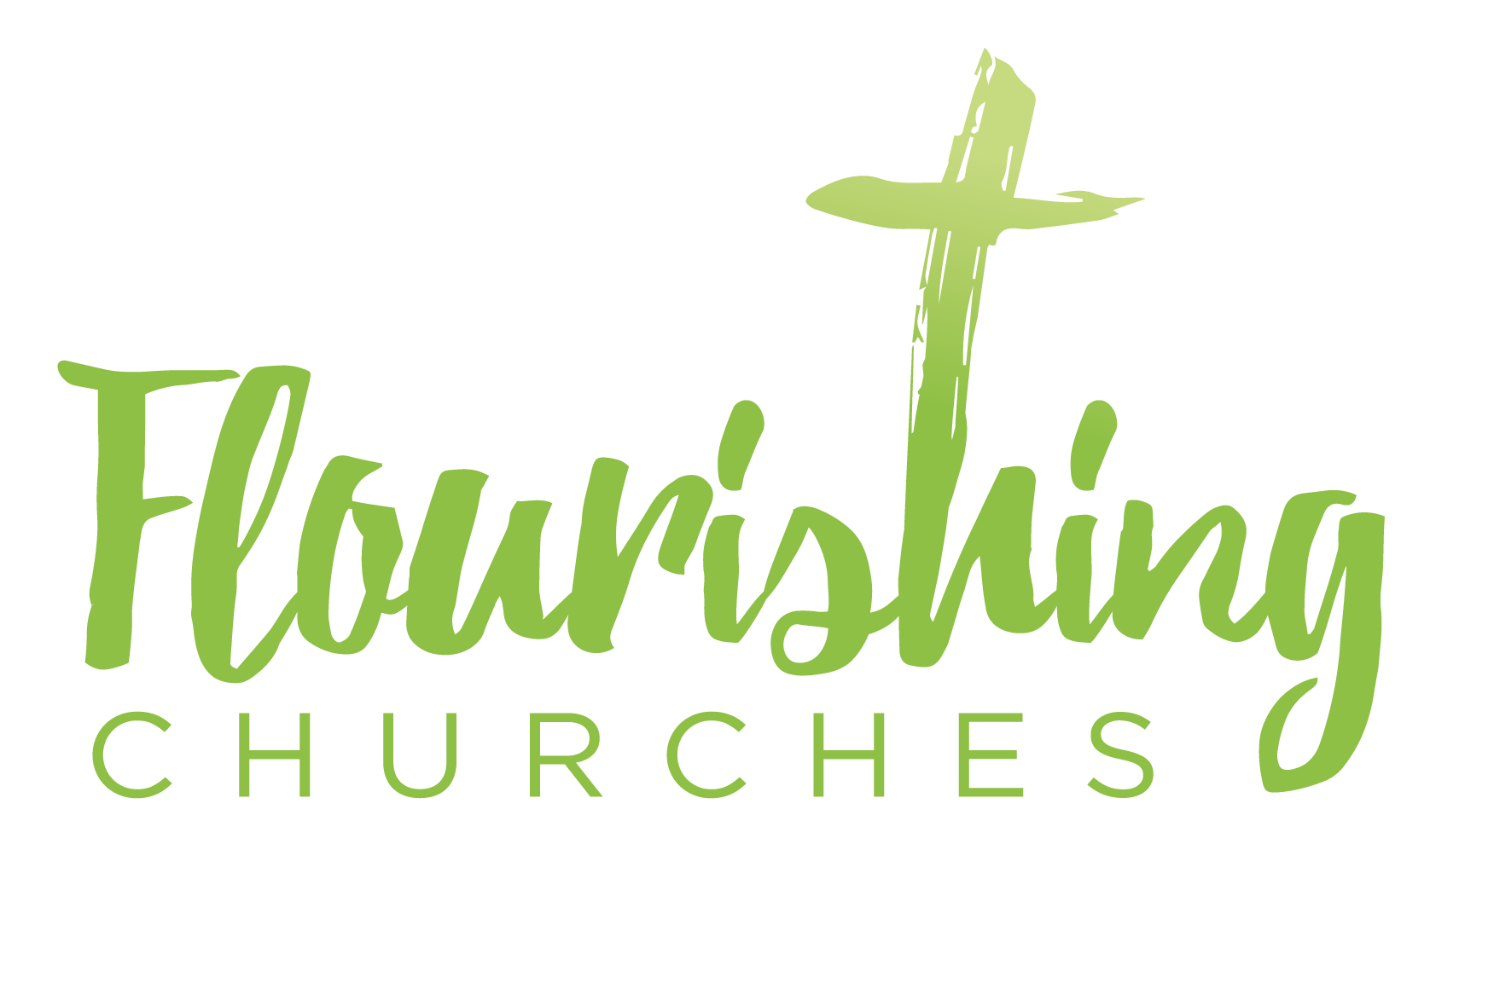
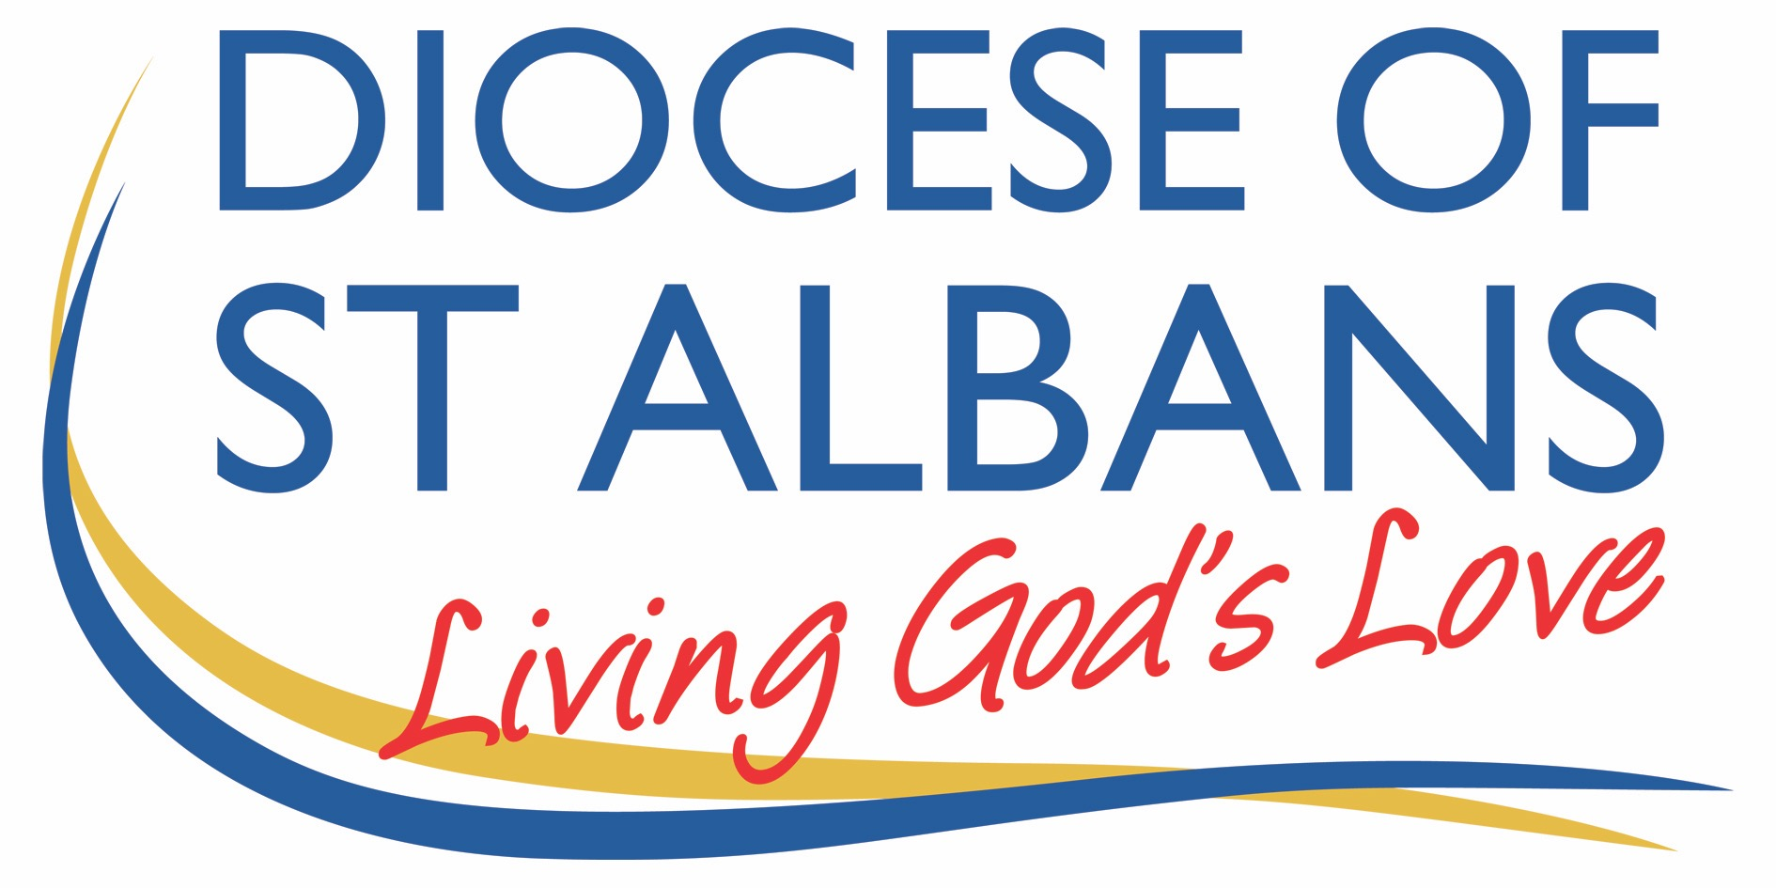

Sunday 1 August 2021: Trinity 9 John 6:24-35

Welcome to Praying Together

Gathering Before God

Make sure you are sitting comfortably.

I am in the presence of the Living God, Father, and of the Son, and of the Holy Spirit. Amen.

Prayer of the Day
Almighty God,
who sent your Holy Spirit
to be the life and light of your Church:
open our hearts to the riches of your grace,
that we may bring forth the fruit of the Spirit
in love and joy and peace;
through Jesus Christ your Son our Lord,
who is alive and reigns with you,
in the unity of the Holy Spirit,
one God, now and for ever Amen

Reflection
Breathe slowly and deeply.
Ask God to speak to you through the passage that you are about to read.

Bible Reading: John 6:24-35Once the crowd realized that neither Jesus nor his disciples were there, they got into the boats and went to Capernaum in search of Jesus. When they found him on the other side of the lake, they asked him, “Rabbi, when did you get here?”
Jesus answered, “Very truly I tell you, you are looking for me, not because you saw the signs I performed but because you ate the loaves and had your fill. Do not work for food that spoils, but for food that endures to eternal life, which the Son of Man will give you. For on him God the Father has placed his seal of approval.” Then they asked him, “What must we do to do the works God requires?” Jesus answered, “The work of God is this: to believe in the one he has sent.” So they asked him, “What sign then will you give that we may see it and believe you? What will you do? Our ancestors ate the manna in the wilderness; as it is written: ‘He gave them bread from heaven to eat.’ Jesus said to them, “Very truly I tell you, it is not Moses who has given you the bread from heaven, but it is my Father who gives you the true bread from heaven. For the bread of God is the bread that comes down from heaven and gives life to the world. ”Sir,” they said, “always give us this bread.” Then Jesus declared, “I am the bread of life. Whoever comes to me will never go hungry, and whoever believes in me will never be thirsty.
Read through the passage once. Read it quietly out loud but say each word out loud.
Try and take note of any words or phrases that strike you.
Say that word or phrase quietly out loud or underline it with a pen.
Read the passage a second time.
As you read, think about how the word or phrase you notice might speak to you today.
After you have read the passage again, sit in silence and try and come up with a sentence or two that sums up what you think the word or phrase means for you today.

Read the passage a third time and prayerfully think about what Christ has said to you.

Some thoughts for Further Reflection:
The background to the Gospel reading is important in setting the scene of our Bible reading today. In John 6 Jesus has just been seen walking on the water by the disciples and before that Jesus has been seen feeding the multitudes with just a little bread and fish.

In the text there is this strange question the people ask Jesus, “What signs will you give so we will believe?” A strange question because many people had seen Jesus feed the multitudes with so little and they have been surprised to find Jesus at Capernaum. They ask him, “How did you get here? Are these not signs enough?”
Jesus in reply does not point back to these signs as a witness to what he was saying to them, rather Jesus takes the people in another direction when he talks about Moses and the bread from heaven.
For the later church the feeding of the multitudes becomes a symbol of the manna from heaven and the receiving of the food of the Eucharist.
In John’s eyes, Jesus while pointing to himself as the bread of heaven, the bread of life, there is a big difference from the bread, the manna, that Moses gave through his intercession to the people. The people in the desert would be hungry every day and would need to be fed again. Whereas when Jesus’ life, the bread from heaven, is received, there will be no more hunger or thirst again. For John the emphasis here is on how Jesus as the life of God gives himself to the people. While Moses’ manna from heaven was a something, the self-giving of Jesus is not a something, it is the Everything, the complete life of God.
As John says earlier in the Gospel, “Out of the fullness of his grace he has blessed us all, giving us one blessing after another.” (John 1:16)

Jesus tells the people that to have life they need to do the work of God and for that they will need health and strength. Health and strength through being nourished with the Bread of Life. If we were to look into the future in this chapter we would see how this teaching was a great cause of trouble, even distress, for the those who were following Jesus as well as those who were opposed to his life and teaching.

Jesus’ response to the question as to what the work of God is, is to believe in him.
A lot of the time when belief is spoken of in the context of the Bible and in the Church we often jump in with both feet and say, the Creed is what I believe as far as I am able to understand it. Or again someone might ask, do you believe in God? Or do you believe in the Resurrection? Asking for some kind of fact or inner knowledge of truth.
For John’s Gospel and the historic Jesus there is another meaning of what it means to believe, which comes up time and time again all the Gospels. To believe is to trust, to put your trust in Jesus’ words, actions, and life which in turn is what it means to receive the bread of life and allow the bread of life to feed our thoughts, our actions, our lives, our love of God, each other and the whole of creation.

Finally, to return to the people’s request for a sign and the request to know what to do, as well as the request to be given the bread of God. In many ways it is the same question asked in different ways , it is the same arrow that emerges from the heart into the direction of Jesus. Something more can be said of the question and the answer Jesus gives, something like this. The way in which the people are to see a sign and to know what the work of God is, in other words to trust God, and the way in which the people are to receive the bread of God will always be from the encounter with God within their own hearts. We are to search our hearts so as to listen to the heart beat of God with them.
Simply put, to go with the answers Jesus gives is not to be found in a something but with the Everything which is the welcoming into our hearts of the true manna from heaven, the life of God, Jesus the bread of God.

OUR PRAYERS
Lord God, you are never far me, you are always close to me,
you never hide your face from me.
Help me, help your church, help your world, to live without fear and worry.
You believe in me, you have put your trust in me.
Help me to trust you and to place my something in your heart within me, for you are my Everything today.
Lord in your love, hear my prayer.

O Merciful God,
Drop down from heaven and refresh my soul with the dew of heaven,
The manna of heaven.
Renew my aching spirit and bless. Lord in your love, hear my prayer.

My brother Jesus, my Lord and my God,
I pray with you in this moment for your world,
my earth, for all that is good, for all that is not.
For all that brings and feeds life and builds trust and for all that frustrates and challenges your love.
For all that mars and darkens your image in us.
For all that scars the earth and sky I inhabit.
In the silence of my heart with you I speak of these things now ……….
May your peace be with those who are ill and those who are dying today.
And to all who are seeking to bring your gift of healing and comfort to people and situations for whom I pray. Lord in your love, hear my prayer.

Because Lord you are near, I am never alone and those whom I love who have died are near to you too.
Grant me with them a share in the bread of Heaven now and in the age that is to come. The age where there is no more hunger, no more thirst and where all are held in the trust you place in each of us. Lord in your love, hear my prayer.

The Lord’s Prayer
Our Father, who art in heaven, hallowed be thy name;
thy kingdom come; thy will be done; on earth as it is in heaven.
Give us this day our daily bread. And forgive us our trespasses,
as we forgive those who trespass against us.
And lead us not into temptation; but deliver us from evil.
For thine is the kingdom, the power and the glory,
for ever and ever. Amen

A Creative Prayer
In the Lord’s Prayer we ask for bread today.
Our daily bread is the bread of God, the Life of God.
As we think on this request, ask your heart,
“Do I truly know in the depth of my being what it is not to be hungry and not to be thirsty?
Whatever your answer make the decision to talk it over with God today and the next day and into the third day.

