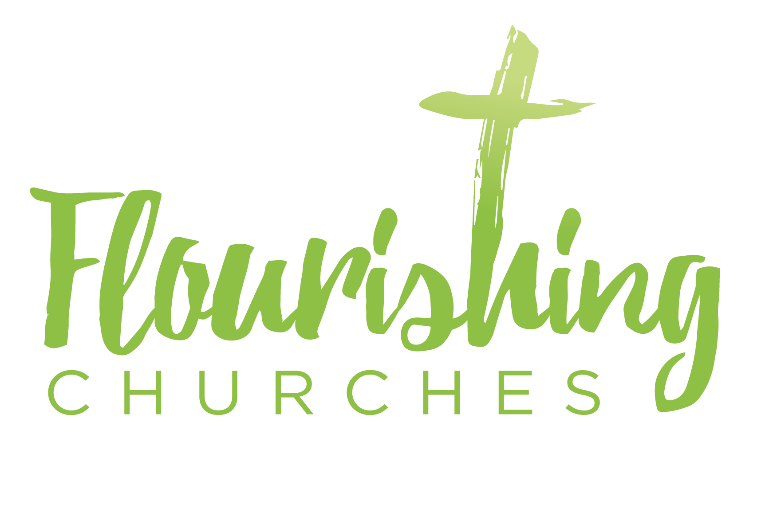
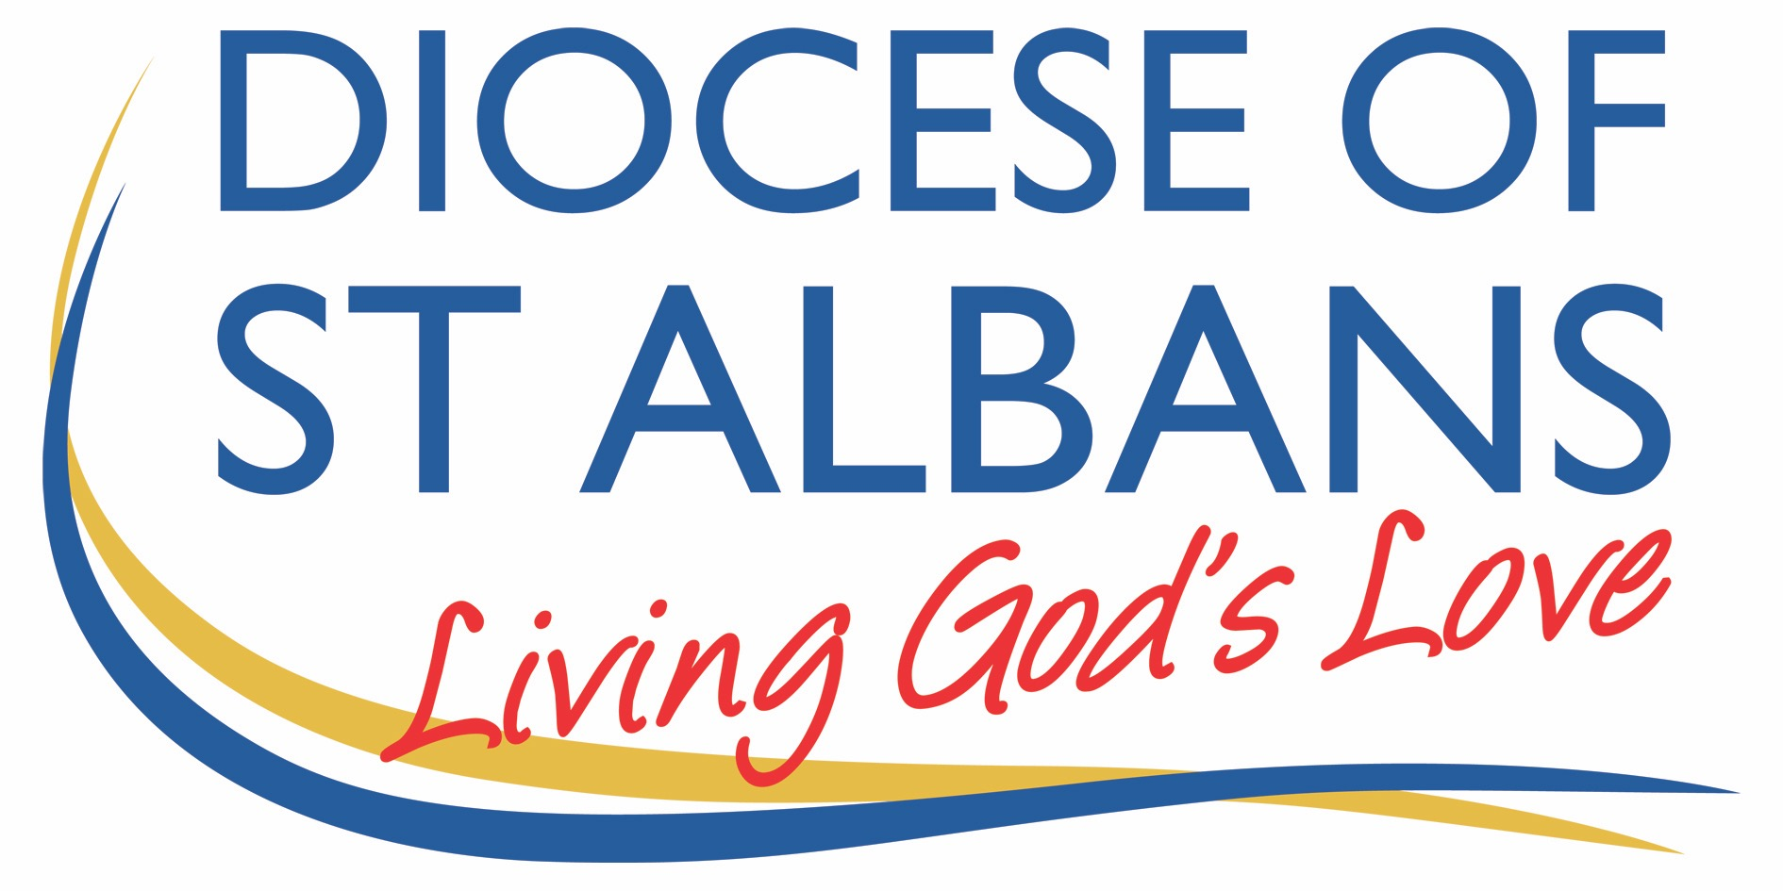

Sunday 18th July 2021 – Trinity 7
Mark 6 v30-34 & 53-end

Welcome to Praying Together

Hymn Suggestions
Alleluia! Sing to Jesus
I Heard the Voice of Jesus Say
I the Lord of Sea and Sky
There are also hymns here from St Martin’s in the Field: https://www.achurchnearyou.com/hub/asset/hymns-and-choral-music

Prayer of the Day:
Generous God,
you give us gifts and make them grow:
though our faith is small as mustard seed,
make it grow to your glory
and the flourishing of your kingdom;
through Jesus Christ our Lord. Amen

Bible Reading:
Mark 6 v30-34 & 53-end
The apostles gathered around Jesus, and told him all that they had done and taught. He said to them, ‘Come away to a deserted place all by yourselves and rest a while.’ For many were coming and going, and they had no leisure even to eat. And they went away in the boat to a deserted place by themselves. Now many saw them going and recognized them, and they hurried there on foot from all the towns and arrived ahead of them. As he went ashore, he saw a great crowd; and he had compassion for them, because they were like sheep without a shepherd; and he began to teach them many things.
When they had crossed over, they came to land at Gennesaret and moored the boat. When they got out of the boat, people at once recognized him, and rushed about that whole region and began to bring the sick on mats to wherever they heard he was. And wherever he went, into villages or cities or farms, they laid the sick in the market-places, and begged him that they might touch even the fringe of his cloak; and all who touched it were healed.

Some thoughts for further Reflection:
Have you ever shut yourself away hoping for 5 minutes peace and quiet – just a moment to rest, breath and close your eyes? I remember when my two children were toddlers there wasn’t a moments peace; constant questions, snacks, wiping up, tidying up, picking up, mopping up. Constant awful noisy toys (I still shudder at the thought of the ghastly plastic tunes!) , Cbeebies, and cries of Mummy! Of course there was great joy and love too, but there were moments when I wanted to lock myself in the downstairs loo and stay there!

We all need a break and moments of rest; whether its children or work or something else, we all have demands on us, and sometimes it feels demanding; even when it is something or someone you love dearly. Rest is important. Time off and time out are crucial. Time to breath, time to stretch our weary bones, time to attend to ourselves.

This is how I read today’s Gospel reading; the disciples and Jesus are tired, it’s been a busy and demanding time. They need a break; so they hop into a boat to find some space and time out. I almost want to imagine them sneaking off to have a nap and a sandwich. But they didn’t get away with it; they were spotted and the crowd followed them.

But, the crowd weren’t like loveable, but mildly irritating toddlers; they had real desperate needs, they were sick, they were lost, they were (a little later in the story after another boat trip across the lake) showing compassion and love for one another, bring their sick to the market place for Jesus to heal them.

Jesus, responds with love; the love of God is inexhaustible, unending and very unlike a stressed parent with toddlers and toys under their feet! Jesus is beyond that limitation and responds with all love and all compassion and all power. The disciples (one imagines!) take His lead and respond as much as they are able; but tiredness makes even the most patient saint grumble and sigh. But the crowds continue to flock.

The crowds, the men and women bringing their children, their parents, their neighbours to be healed are seeking something profound. Yes, they are seeking wellness and wholeness (who isn’t?) but I think something deeper moved Jesus profoundly. ‘They were like sheep, without a shepherd’ And Jesus is the Good Shepherd. He calls all sheep, they hear his voice and he gathers them as one.

This is beyond bodily healing, this is about homecoming. (and I write this as the England win over Denmark is being celebrated and shouts of ‘it’s coming home’ are ringing throughout my house – who knows what the final will bring!) But homecoming is a powerful and profound sentiment. The lost sheep who are guided back to the safety of fold. The lost coin that is searched for and found and treasured. A lost, errant son who is welcomed home with arms outstretched. A lost woman who is given life giving water and valued as a daughter. Lost disciples who do not know the way to the Father are told that Jesus is the way, the truth and the life.

In Christ we find our home. In Christ we find perfect love and welcome and compassion. In Christ we are enfolded in his love. That is what the crowds wanted. They wanted a safe home, where they are called by name, loved into completeness, and given sweet life-giving water to drink. And they glimpsed this home in Christ.

May you, as you read this today, and ponder these words, hear Jesus calling your name, and may you know his compassionate gaze upon you, and may you also know some peace and rest.
Kate Peacock

OUR PRAYERS

In our prayers today, I invite you to pray the words of this hymn. You may like to pray it through twice once for yourself and your need for rest and secondly for someone (or a family or group of people) who you know who needs a break right now.

I heard the voice of Jesus say,
‘Come unto me and rest;
lay down, thou weary one, lay down
thy head upon my breast.’
I came to Jesus as I was,
so weary, worn and sad;
I found in him a resting place,
and he has made me glad.

I heard the voice of Jesus say,
‘Behold, I freely give
the living water, thirsty one;
stoop down and drink and live.’
I came to Jesus, and I drank
of that life-giving stream;
my thirst was quenched, my soul revived,
and now I live in him.
I heard the voice of Jesus say,
‘I am this dark world’s light;
look unto me, thy morn shall rise,
and all thy day be bright.’
I looked to Jesus, and I found
in him my star, my sun;
and in that light of life I’ll walk
till trav’lling days are done. Amen.
A prayer concerning the Coronavirus
God of compassion,
be close to those who are ill, afraid or in isolation.
in their loneliness, be their consolation;
in their anxiety, be their hope;
in their darkness, be their light;
through him who suffered alone on the cross,
but reigns with you in glory,
Jesus Christ our Lord. Amen.

An act of spiritual Communion
My Jesus,
I believe that You
are present in the Most Holy Sacrament.
I love You above all things,
and I desire to receive You into my soul.
Since I cannot at this moment
receive You sacramentally,
come at least spiritually into my heart.
I embrace You as if You were already there and unite myself wholly to You.
Never permit me to be separated from You. Amen.

The Lord’s Prayer
Our Father, who art in heaven, hallowed be thy name;
thy kingdom come; thy will be done;
on earth as it is in heaven.
Give us this day our daily bread.
And forgive us our trespasses,
as we forgive those who trespass against us.
And lead us not into temptation; but deliver us from evil.
For thine is the kingdom,
the power and the glory, for ever and ever. Amen.

To keep up to date with resources and dates from the Flourishing Churches team, please follow us on Facebook: https://www.facebook.com/Flourishing-Churches-St-Albans-Diocese-105528844479183
Also St Albans Diocese Youth Service: https://www.facebook.com/stalbansdys/
And Children’s Ministry St Albans Diocese: https://www.facebook.com/stalbanscme

