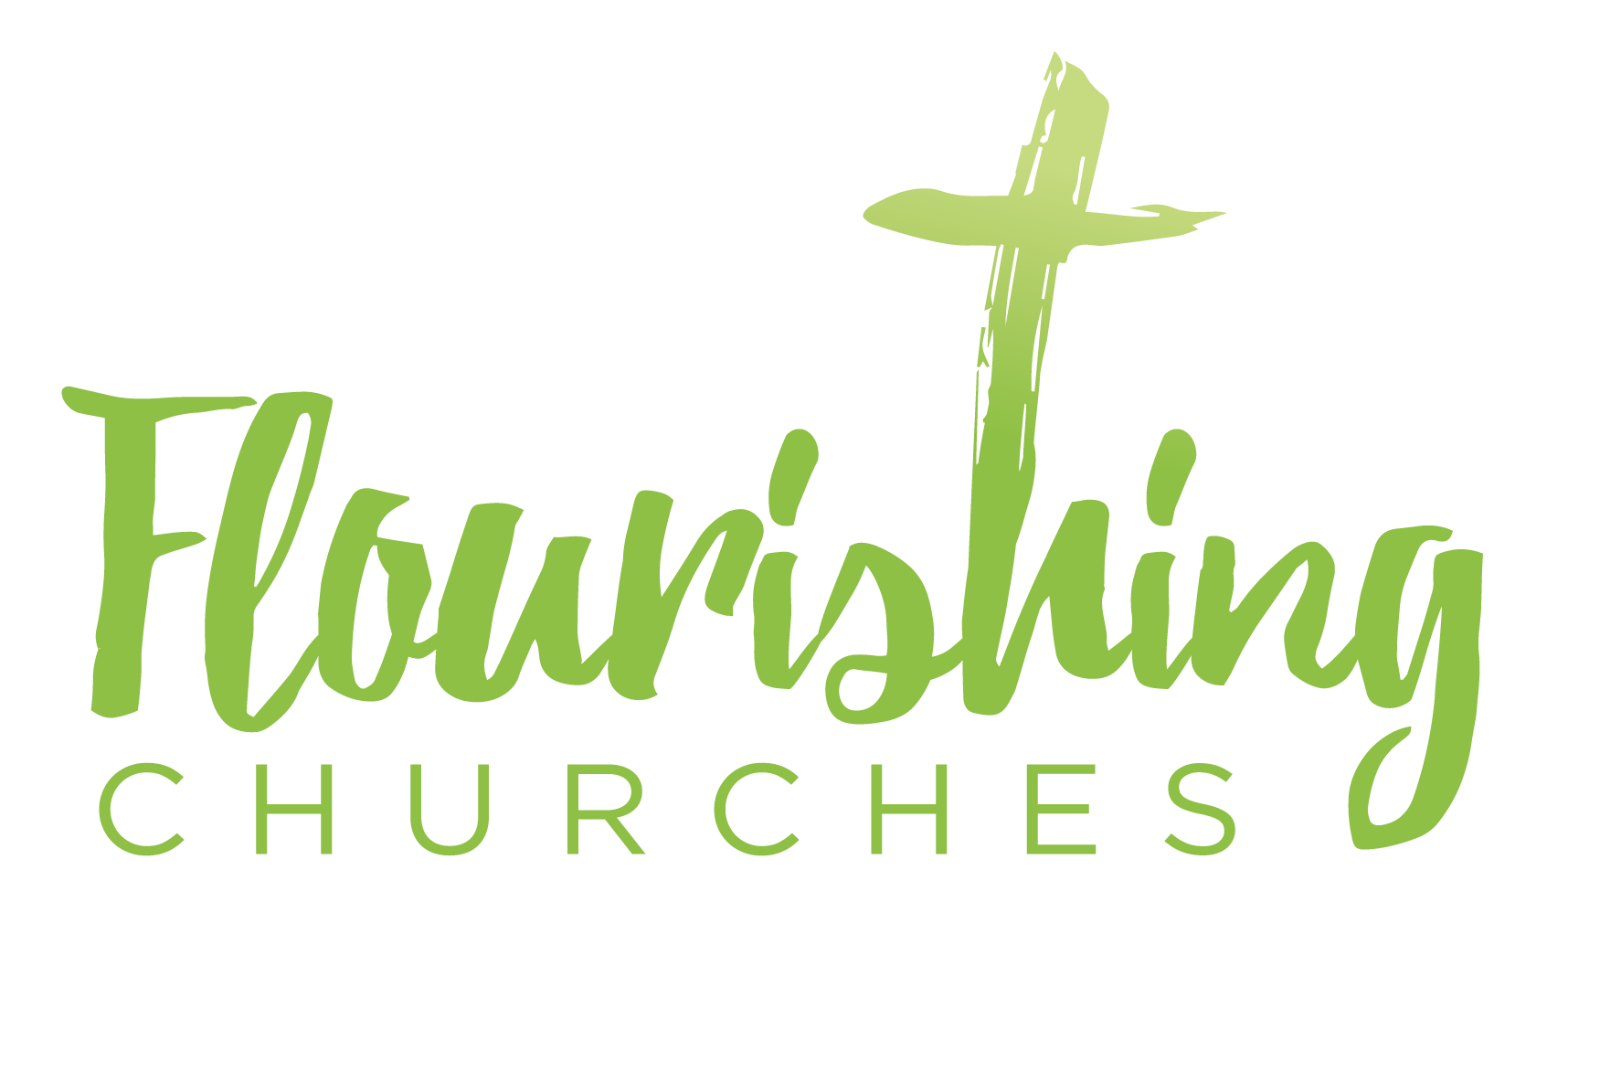
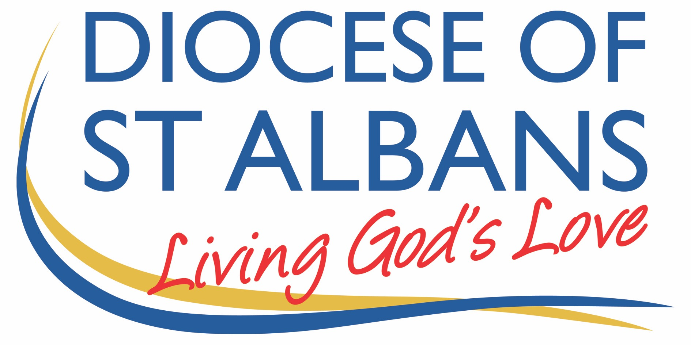

Sunday 25th October 2020: Bible Sunday – Matthew 24.30-35

Welcome to Praying Together but Separately

Hymn Suggestions

There is a Hope
Thy Word is a Lamp Unto my Feet
Beauty for Brokenness
Lord Thy Word Abideth
Tell me the old, old story

Gathering Before God

Make sure you are sitting comfortably.

I am in the presence of the Living God, Father, and of the Son, and of the Holy Spirit. Amen.

Prayer of the Day

Merciful God,
teach us to be faithful in change and uncertainty,
that trusting in your word
and obeying your will
we may enter the unfailing joy of Jesus Christ our Lord. Amen

Reflection

Breathe slowly and deeply.
Ask God to speak to you through the passage that you are about to read.

Bible Reading: Matthew 24.30-35

Then the sign of the Son of Man will appear in heaven, and then all the tribes of the earth will mourn, and they will see “the Son of Man coming on the clouds of heaven” with power and great glory. And he will send out his angels with a loud trumpet call, and they will gather his elect from the four winds, from one end of heaven to the other.
‘From the fig tree learn its lesson: as soon as its branch becomes tender and puts forth its leaves, you know that summer is near. So also, when you see all these things, you know that he is near, at the very gates. Truly I tell you, this generation will not pass away until all these things have taken place. Heaven and earth will pass away, but my words will not pass away.

Read through the passage once. Read it quietly out loud but say each word out loud.
Try and take note of any words or phrases that strike you.
Say that word or phrase quietly out loud or underline it with a pen.
Read the passage a second time.
As you read, think about how the word or phrase you notice might speak to you today.
After you have read the passage again, sit in silence and try and come up with a sentence or two that sums up what you think the word or phrase means for you today.

Read the passage a third time and prayerfully think about what Christ has said to you.

Some thoughts for Further Reflection:

Bible Sunday.

The reading for today is for Bible Sunday: no doubt chosen for the closing verses: ‘Heaven and earth will pass away, but my words will not pass away.’ The reading, however, is not a simple one. Rather than work through these verses. Here are a few thoughts relevant to Bible Sunday.

Lots of us have a deep love and appreciation for the Bible. For most people, however, the Bible is long, in some places pretty boring and in other places pretty hard to understand. Most folks don’t realise it is not a book, but a collection of books: all of which were written by different people, at different times, and in styles of literature.

But here’s something I believe about the Bible: the Bible is Holy Scripture, it is a collection of writings inspired by God. It is, also, the story of human beings trying to understand God, and getting it, for the most part, wrong. And that makes it a great book, because pretty much everyone has at some point asked a question like: what is the point of all this? Why am I here? Who am I? And you may have even asked the question, whose am I?

1. Creation

As we consider the story of the Bible, and our place in that story, a good question for us to ask ourselves is why did God create us? Genesis is not a book about how God created. There are plenty of science books that deal with that. An even tougher question than, ‘What is the universe?’, might be the questions of, ‘Why is there a universe? Why is there a story and why are we here?’

God did not create you and I because he was lonely: far from it. The Trinitarian God – Father, Son and Holy Spirit, is something a little like the perfect marriage. A perfect married couple (I know: no such thing!) have perfect love for one another; they don’t then decide to have children because they are getting bored of one another’s company, or they are getting lonely. They decide to have children because of that love that they have – they want to share the love.

And that is why God created.

It is an important reason. We might cite Psalm 8 here,

What are human beings that you are mindful of them,
mortals that you care for them?
Yet you have made them a little lower than God,
and crowned them with glory and honour.
You have given them dominion over the works of your hands;
you have put all things under their feet,
all sheep and oxen,
and also the beasts of the field,
the birds of the air, and the fish of the sea,
whatever passes along the paths of the seas.

What a great story the Bible tells – you are not an accident.

You have place and purpose; you have family and you belong. As contemporary western society continues with stress caused by working too hard, rise in alcoholism, increasing suicide rates, teenagers with eating disorders or struggling with issues of para-suicide and self-harm; it pays to remind ourselves, that the story we think we all know - the story of creation - the story, not of how, but of why - has more to say to us today than we might imagine. You are not what you do. Your identity is not described by your failures or your successes. You are made in the image of God to share in God’s love.

2. Un-Creation

Of course, there is a problem looming, let us call this problem un-creation.

Humanity undoes creation.

By the third chapter of the beginning of the story we come across the undoing of creation. It is a famous story, and like a lot of famous stories it is usually told wrong.

We imagine that this is a story about the devil, apples, and things we are not allowed to do. This story is actually about what we are allowed to do: freedom. There is no apple, and, in a controversial statement I will go onto explain, it is more about a talking snake than it is about the devil.

There’s no apple because apples weren’t around in the ancient near or middle east till much later, so the fruit was more likely to be an orange, or perhaps a banana: I have never liked bananas.

There is no devil because that part of the story clearly opens up with the phrase, “Now the serpent was more crafty than any of the wild animals God had made.”

This puts the snake firmly into the ‘animals created by God category’. Church history has always interpreted the snake as being the devil and I won’t argue, on this occasion, with 2,000 years of church tradition. But Eve didn’t know it was the devil, she knew it was a creature, and therefore she should have dominion over it like all the creatures. But instead she listens to the serpent, allows the serpent to distort God’s truth.

Why was there something that Adam and Eve weren’t allowed to do? And if God really didn’t want Adam and Eve to eat the fruit of that tree, why not put the tree somewhere Adam and Eve wouldn’t want to go (insert your own place name as an example here)?

There has to be a tree, and it has to be right in the middle of the story, because there has to be real choice, there has to be real choice because there has to be real freedom. If there were not choice there would be no freedom. We are, after all, made in the image of God.

People sometimes ask me if that story actually happened, if there was a real Adam and Eve, and if they really decided to not listen to God and decided to try and go their own way: do it alone.

The point is that that story is happening. Every day and in all kinds of circumstances, there are people trying to do this on their own, ignoring God, saying, ‘we’ve got this, we know why we are here and what we have to do.’

3. Re-creation

But there is re-creation, there is always re-creation. Sin is not the end of the story and never will be. What sin has un-created God will re-create. But it takes a while. Sin spreads like wildfire. Adam and Eve make a mistake, then Cain kills Abel. Then Cain’s offspring, a guy called Lamech, kills someone and instead of feeling bad is boasting about it.

Creation refuses to be God’s creation and so God acts. The story of Noah is not so much about a huge expanse of water, the story of Noah is the story of God’s own heart, and in this account we get an insight into God’s heart, in perhaps the most intimate verses in the Bible.

Consider Genesis 6:6 and 8:21,

⁶And the Lord was sorry that he had made humankind on the earth, and it grieved him to his heart.

²¹…the Lord said in his heart, ‘I will never again curse the ground because of humankind, for the inclination of the human heart is evil from youth; nor will I ever again destroy every living creature as I have done.

Both verses give us an insight into the heart of God. In the first God is grieved and seems to regret creation. But once the flood is over, we get another insight into the heart of God, and God seems to have changed his mind. Right at the beginning of the story of the Bible we learn that hope depends on a move of God.

4. Incarnation

And that brings us to the next theme of God’s story. We will fast forward through hundreds of years of rebellion, messages from prophets, kings – one or two of whom are good, the overwhelming majority are bad - and we find ourselves in a small, insignificant village in 1st century Palestine.

God is a giving and loving God. In love God gives himself to the world in the incarnation.

The incarnation ends in crucifixion. God becomes that which God would save. He became human in order to save humanity. The cross offends humanity, victory arriving through apparent defeat seems strange, the door of heaven is propped open with the dead body of the Messiah, who is God.

If this story is our story, then there comes a point when we offend the world with the story that we are living. And we should certainly remember that. If, on occasions, you don’t feel weird being a follower of Christ, then you may not be following closely enough.

We have to live differently, and so we are called to follow Jesus, to do what Jesus did. We make this overly complicated, when all it really means is this: There are two types of people in the world: firstly, your neighbours, people who are like you: love them. Secondly, there are enemies, people not like you: love them.

Love them like God loves you: you are not an accident. The universe is not the work of a fool, there is a plan and a purpose, and you are part of it. Amen.

Harry Steele

A Poem for Reflection

God made
Adam bit
Noah arked
Abraham split
Jacob fooled
Joseph ruled
Bush talked
Moses balked
Pharaoh plagued
People walked
Sea divided
Tablets guided
Promise landed
Saul freaked
David peeked
Prophets warned
Jesus born
God walked
Love talked
Anger crucified
Hope died
Love rose
Spirit Flamed
Word spread
God remained

(by Rev Dana Livesay, Wanganui, New Zealand. Top of the Morning Book of Incredibly short stories, selected by Brian Edwards, 1997, Tandem Press, Auckland, p.41)
Prayers
The prayers for Bible Sunday are based on the Beatitudes and taken from John Pritchard’s ‘The Intercessions Handbook, p.110

Lord we remember before you those who are struggling in life, and feel they haven't got enough strength inside them to cope.

Blessed are the poor in spirit
for theirs is the kingdom of heaven.

We remember before you those who have lost someone very special to them, and are wandering along the dark valley of bereavement.

Blessed are those who mourn
for they will be comforted.

We remember before you those who deliberately choose not to push their way through life treading on other people, but try to live in a gentler, more generous way.

Blessed are the meek
for they will inherit the earth.

We remember before you those who give their time and effort to important causes, to fight against hunger, torture, or the exploitation of our planet.

Blessed are those who hunger and thirst for righteousness
for they will be filled.

We remember before you those who turn their back on vengeance and bitterness, and so try to stop the cycles of destruction in our world, by showing the alternative way of Jesus.

Blessed are the merciful for they will be shown mercy.
We remember before you the people who inspire us to live better lives: those who have a love and a joy in them which make us ashamed, and determined to do better.

Blessed are the pure in heart
for they will see God.

We remember before you those who both on the world stage and in ordinary living give themselves to the task of making peace a reality.

Blessed are the peacemakers
for they will be called the children of God.

We remember before you those who refuse to compromise on the truth, and are prepared to pay the price.

Blessed are those who are persecuted because of righteousness
for theirs is the kingdom of heaven.

And blessed are we all when people insult us and falsely say all kinds of things about us because of Jesus Christ.
Let us even rejoice and be glad, because great is our reward in heaven. Amen
A PRAYER CONCERNING THE CORONAVIRUS
God of compassion, be close to those who are ill, afraid or in isolation. In their loneliness, be their consolation; in their anxiety, be their hope; in their darkness, be their light; through him who suffered alone on the cross, but reigns with you in glory, Jesus Christ our Lord. Amen.
The Lord’s Prayer

Our Father, who art in heaven, hallowed be thy name;
thy kingdom come; thy will be done; on earth as it is in heaven.
Give us this day our daily bread. And forgive us our trespasses,
as we forgive those who trespass against us.
And lead us not into temptation; but deliver us from evil.
For thine is the kingdom, the power and the glory,
for ever and ever. Amen

