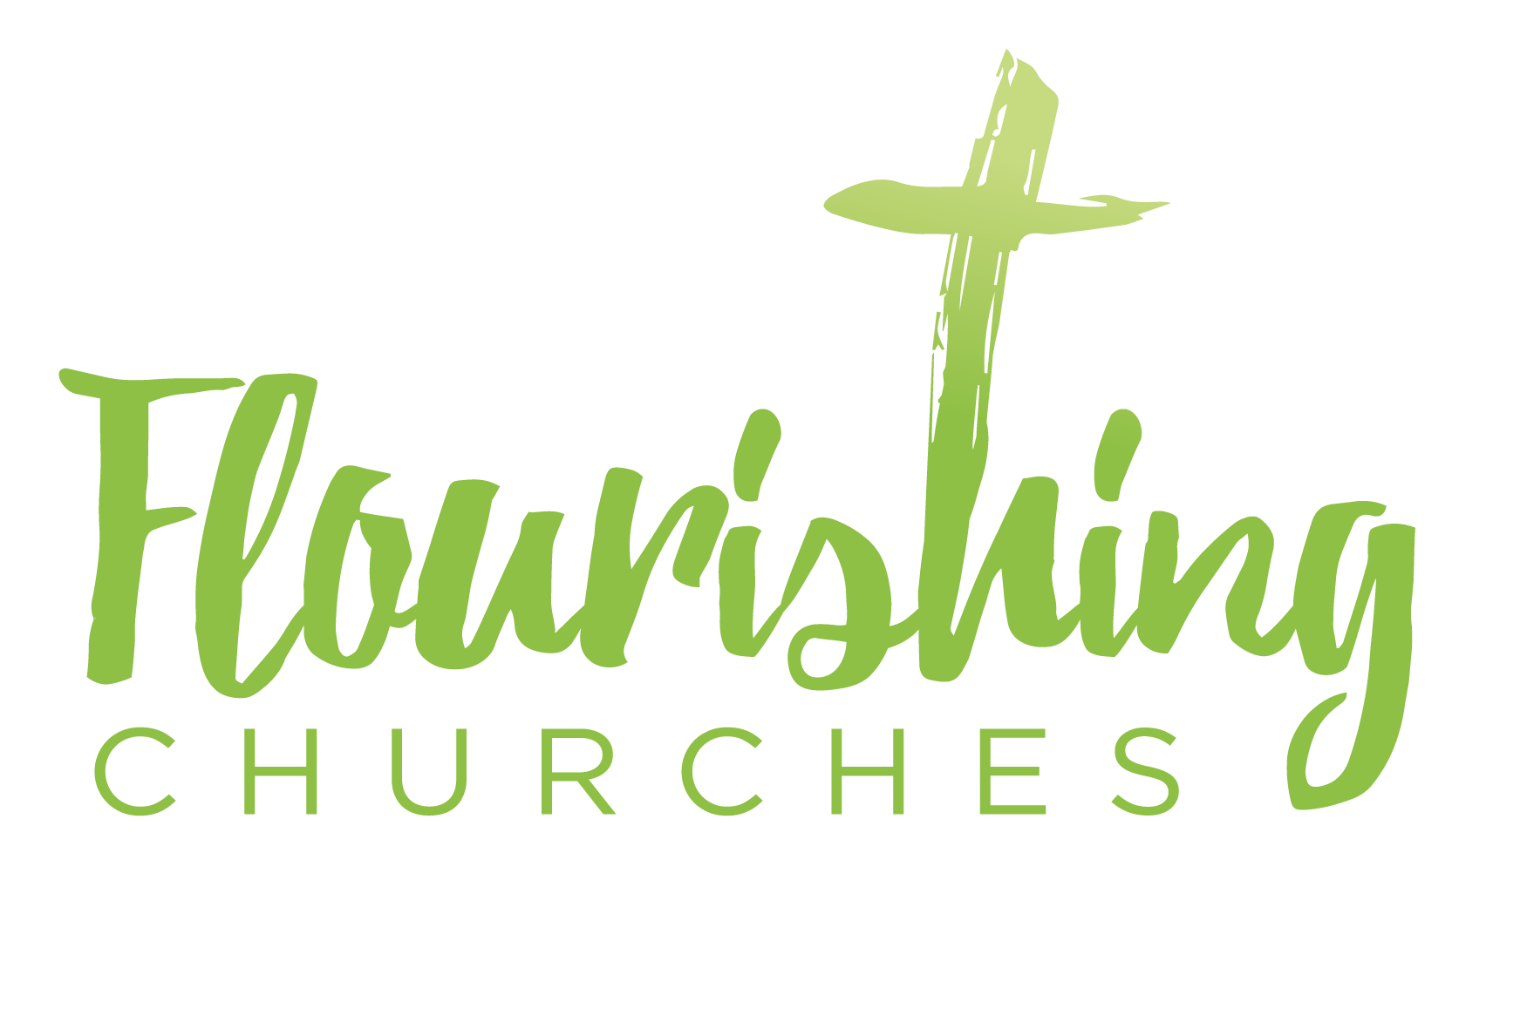
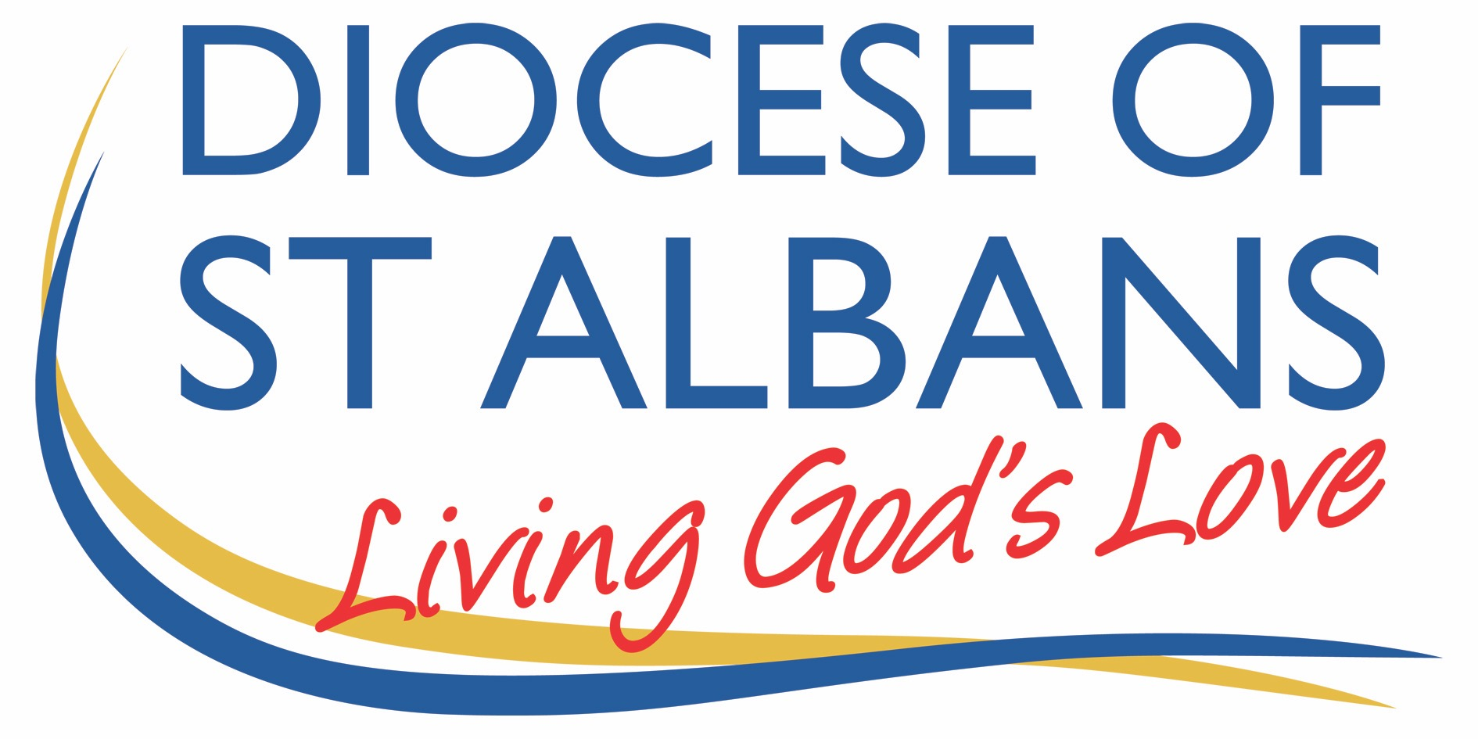

Sunday August 9th ~ Trinity 9: Matthew 14:22-33

Welcome to Praying Together but Separately

Gathering Before God

Make sure you are sitting comfortably.
I am in the presence of the Living God, Father, and of the Son, and of the Holy Spirit. Amen.

Prayer of the Day
Gracious Father,
Revive your Church in our day.
And make her holy, strong and faithful,
For your glory’s sake
In Jesus Christ our Lord
Amen.

Reflection

Breathe slowly and deeply.
Ask God to speak to you through the passage that you are about to read.

Bible Reading: Matthew 14.22-33

Jesus made the disciples get into the boat and go on ahead to the other side, while he dismissed the crowds. And after he had dismissed the crowds, he went up the mountain by himself to pray. When evening came, he was there alone, but by this time the boat, battered by the waves, was far from the land, the wind was against them. And early in the morning he came walking towards them on the lake. But when the disciples saw him walking on the lake, they were terrified, saying, ‘It is a ghost!’ And they cried out in fear.
But immediately Jesus spoke to them and said, ‘Take heart, it is I; do not be afraid.’ Peter answered him, ‘Lord, if it is you, command me to come to you on the water.’ He said, ‘Come.’ So, Peter got out of the boat, started walking on the water, and came towards Jesus. But when he noticed the strong wind, he became frightened, and beginning to sink, he cried out, ‘Lord, save me!’ Jesus immediately reached out his hand and caught him, saying to him, ‘You of little faith, why did you doubt?’ When they got into the boat, the wind ceased. And those in the boat worshipped him, saying, ‘Truly you are the Son of God.’

Some thoughts for further Reflection:

In the Gospel today, Peter says to Jesus,
‘Lord, if it is you, command me to come to you on the water.’
When we hear Peter’s words to Jesus, we often think that Peter is putting to the test what he is seeing and hearing. Is it really Jesus or a ghost?
We often then understand that the story is speaking about the need to have faith and not to doubt.
Jesus says to Peter, ‘You of little faith, why did you doubt?’
Sometimes people will take another step and reflect on the moment that Peter starts walking on the water. He becomes afraid of what he is doing and starts to sink in the waves as the wind blows hard. In that moment Peter takes his eyes off Jesus and looks at himself and so his situation becomes perilous. Hence the realisation that what is important in times of stress and trouble is to keep our eyes, our focus, our trusting on Jesus and not on ourselves and on what we can and cannot control. This is simple yet hard.
Similarly, this understanding is revealed in the story of King Jehoshaphat in the Second Book of Chronicles (20:12) when the king says, “We do not know what to do, but our eyes are on you.”

The situation that Peter finds himself in as he walks towards Jesus and the words of Jesus are very similar to the occasion when Jesus is in the boat sleeping in a big storm and the disciples believe they are going to die. They cry out to Jesus to save them and Jesus asks them “where is your faith”?, their trust in Him. In both stories there is the truth that however difficult and confusing, if not life threating things are for us, Jesus is with us, in the boat, on the lake, and all is well. This is not to say that whatever we are facing will always work out in ways we want it to and often the opposite can be the truth. What is true is that Jesus is with us and in the end, whenever that will be, all will be well in this age and in the next.

What is often not spoken of is Peter’s action of getting out of the boat. Peter’s action tells us something very important about trust and doubt. It is only Peter’s great trust and confidence in Jesus, through grace, which enabled him to want to and then to get out of the boat into the sea.
Peter’s trust in Jesus was very strong and not weak. And yet even in a life of someone who has so much trust in Jesus there are moments when the trust is shaken to the core and starts to sink in the doubts of the sea of the circumstances of life. If this can happen to Peter, who has so much faith in Jesus, why would we ever think that we too would not have such moments where trust is challenged and doubts seek our destruction.
Just as Jesus reaches out and pulls Peter from the waves so will God bring us to the safety of his embrace. Trust and doubt often walk hand in hand on the land and on the sea.

Creative Prayer activity for at home

Imagine that you are a boat alone in a storm, when you see Jesus walking towards you on the water.
Think and speak to Jesus as to what it would it mean for you to climb out of the boat to meet him.
Think and speak to Jesus as what you find most difficult in trusting yourself to him and to the waves, even in the face of doubt when trust is shaken to the core.

OUR PRAYERS

God of trust you place your trust within us, however small we are, however small our faith is. You love us for who we are, and for what we will become through your grace,
even when doubt shakes our trust in you to the core.
This day and everyday strengthen our trust in you so that at your call we will have the courage to step out of the safety of the boat to meet you.
Lord in your mercy,
Hear our prayer.

God of the stillness and of the storm, in calling us we ask you to enlighten our hearts and our minds to know how the way of your kingdom will grow in us and in your world,
so that the earth may come as it is heaven.
In the moments when our eyes lose you, and fear and anxious thoughts look to overwhelm us and we sink, reach quickly with your hand and lift our gaze to you again, where all will be well.
Lord in your mercy,
Hear our prayer.

God of Peter, for whom you entrust your Church, renew and inspire your Church as you did for Peter with the courage to risk moving from the safety of what we know to what is unknown. Grant your Church, today, the grace to share your kindness and concern for the community in which your church is placed.
May the many find their way home to you even if means walking on the water.
Lord in your mercy,
Hear our prayer.

Healing Christ, we pray for the sick, and all who are battered by the waves and wind, the storms of trouble.
We are praying for all those who are affected in different ways by the coronavirus.
For those tired through work, those who have lost work, those who are physically ill.
For those who are struggling mentally,
For those who are lost in the storm and have little hope.
We name those we know in our heart now to you.
Lord in your mercy,
Hear our prayer.

Lord of all trust, your saints and angels in heaven and on earth sing your praise echoing throughout the universe the sound of your confidence in us.
Welcome and embrace in your kingdom all who have died and yet remain in our hearts.
Bless them as you bless us as we speak their names to you in our hearts.
Lord in your mercy,
Hear our prayer.

Holy Spirit travel with us this day and in the days of this week in ways we can understand so that we can travel in your footsteps. Amen

A prayer concerning the Coronavirus
God of compassion,
be close to those who are ill, afraid or in isolation.
in their loneliness, be their consolation;
in their anxiety, be their hope;
in their darkness, be their light;
through him who suffered alone on the cross,
but reigns with you in glory,
Jesus Christ our Lord.
Amen.

An act of spiritual Communion
My Jesus,
I believe that You
are present in the Most Holy Sacrament.
I love You above all things,
and I desire to receive You into my soul.
Since I cannot at this moment
receive You sacramentally,
come at least spiritually into my heart.
I embrace You as if You were already there and unite myself wholly to You.
Never permit me to be separated from You.
Amen.

The Lord’s Prayer
Our Father, who art in heaven, hallowed be thy name;
thy kingdom come; thy will be done;
on earth as it is in heaven.
Give us this day our daily bread.
And forgive us our trespasses,
as we forgive those who trespass against us.
And lead us not into temptation; but deliver us from evil.
For thine is the kingdom,
the power and the glory, for ever and ever. Amen.

