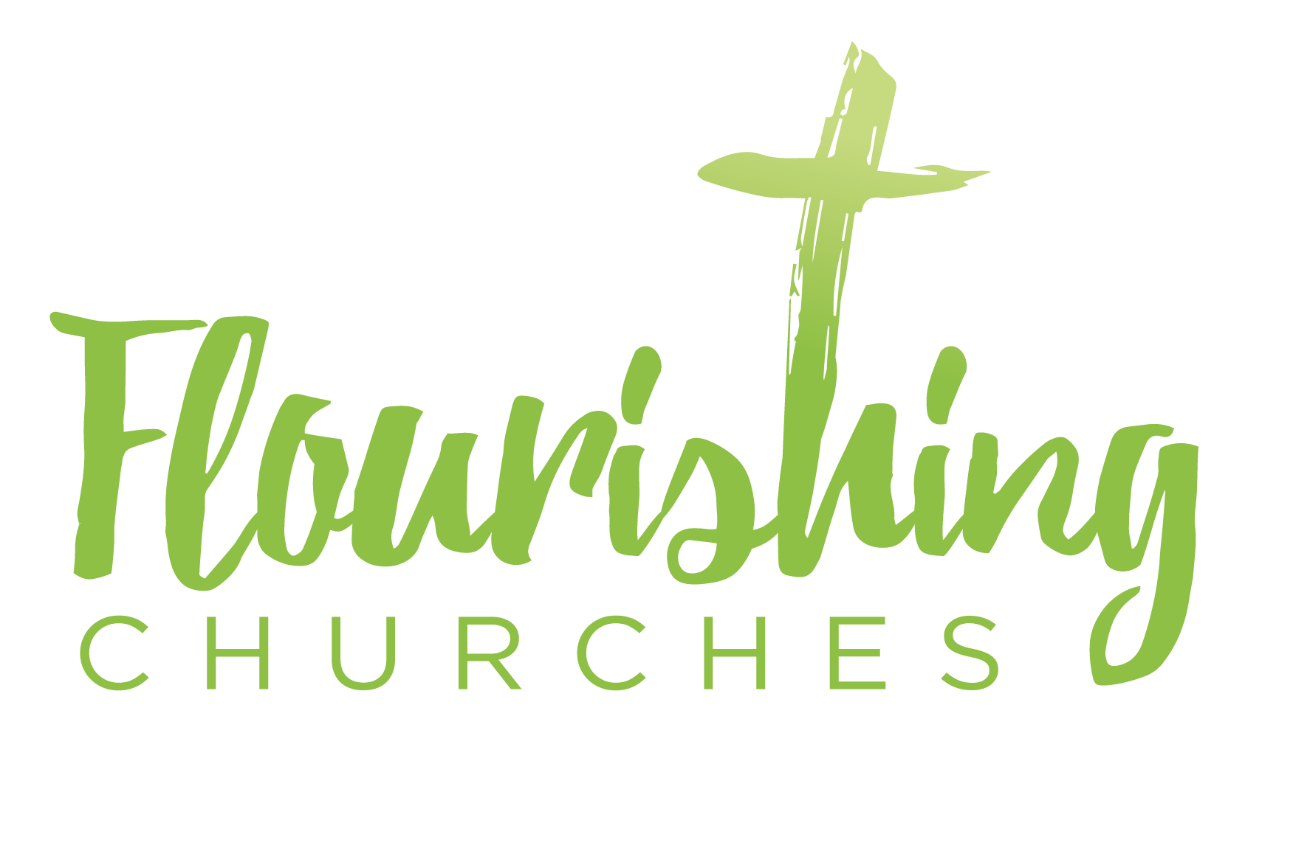
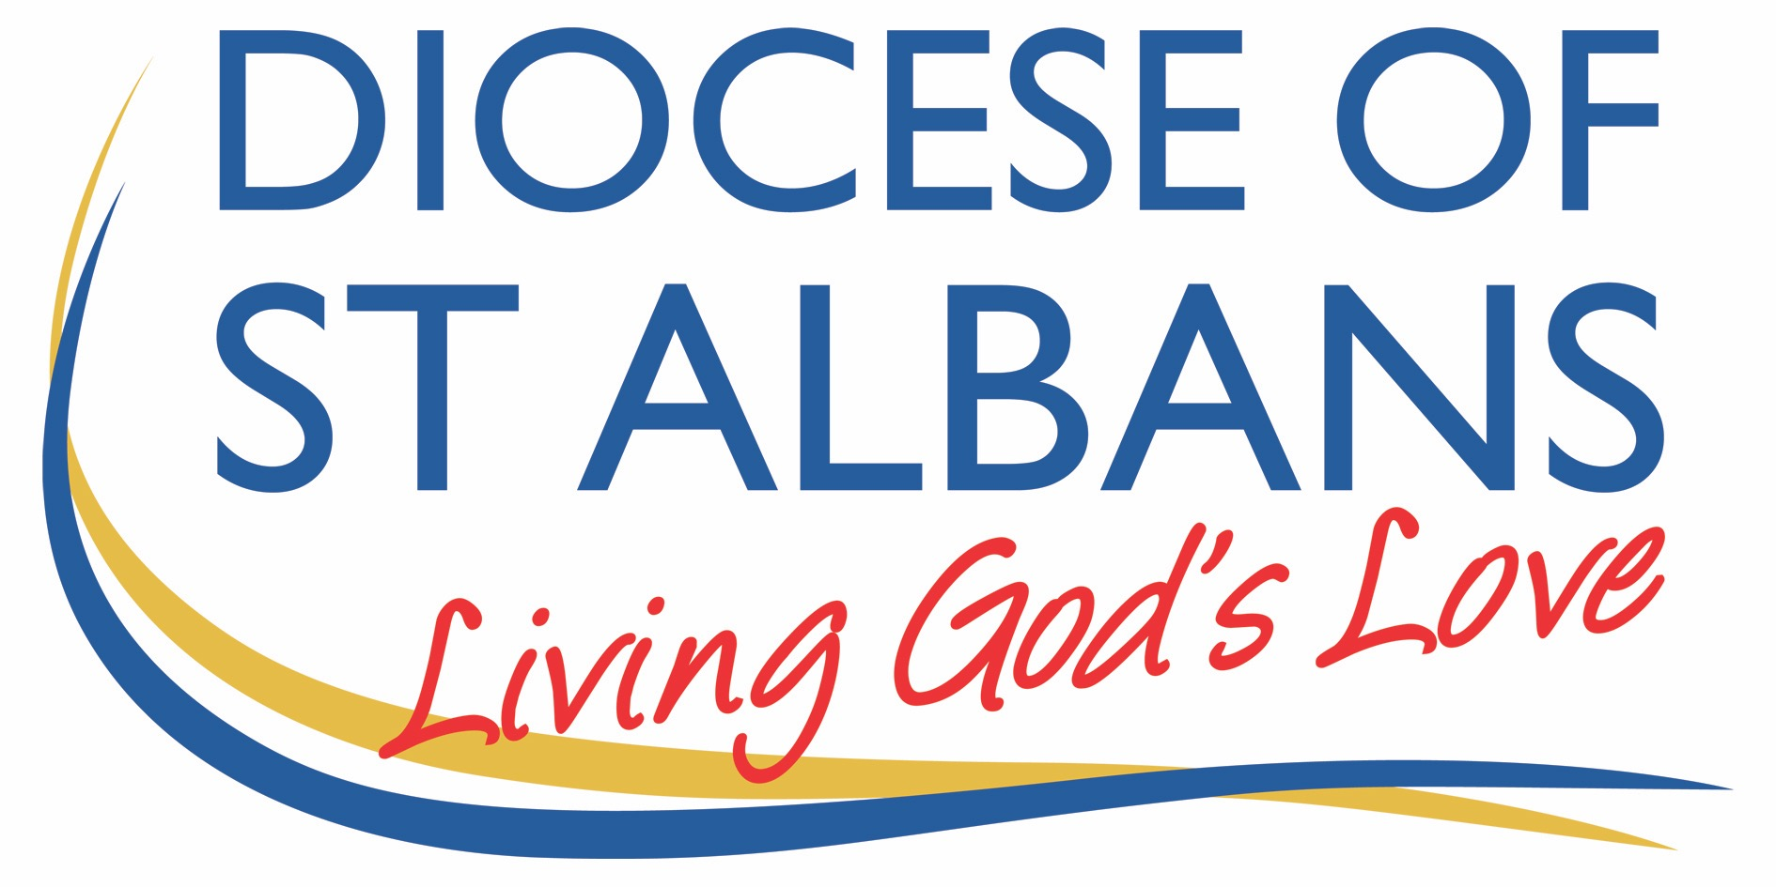

Sunday July 5th ~ Trinity 4: Romans 7.15-25a and Matthew 11.16-19,25-30

Welcome to Praying Together but Separately

Gathering Before God

Make sure you are sitting comfortably.

I am in the presence of the Living God, Father, and of the Son, and of the Holy Spirit. Amen.

Prayer of the Day
Gracious Father,
by the obedience of Jesus
you brought salvation to our wayward world:
draw us into harmony with your will,
that we may find all things restored in him,
our Saviour Jesus Christ.Amen.

Reflection

Breathe slowly and deeply.
Ask God to speak to you through the passage that you are about to read.

Bible Reading: Matthew 11.16-19 and 25-30

‘But to what will I compare this generation? It is like children sitting in the market-places and calling to one another, “We played the flute for you, and you did not dance; we wailed, and you did not mourn.”
For John came neither eating nor drinking, and they say, “He has a demon”; the Son of Man came eating and drinking, and they say, “Look, a glutton and a drunkard, a friend of tax-collectors and sinners!” Yet wisdom is vindicated by her deeds.’
At that time Jesus said, ‘I thank you, Father, Lord of heaven and earth, because you have hidden these things from the wise and the intelligent and have revealed them to infants; yes, Father, for such was your gracious will. All things have been handed over to me by my Father; and no one knows the Son except the Father, and no one knows the Father except the Son and anyone to whom the Son chooses to reveal him.
‘Come to me, all you that are weary and are carrying heavy burdens, and I will give you rest. Take my yoke upon you, and learn from me; for I am gentle and humble in heart, and you will find rest for your souls. For my yoke is easy, and my burden is light.’

Read through the passage once. Read it quietly out loud but say each word out loud.
Try and take note of any words or phrases that strike you.
Say that word or phrase quietly out loud or underline it with a pen.
Read the passage a second time.
As you read, think about how the word or phrase you notice might speak to you today.
After you have read the passage again, sit in silence and try and come up with a sentence or two that sums up what you think the word or phrase means for you today.

Read the passage a third time and prayerfully think about what Christ has said to you.

Some thoughts for further Reflection:

Our Gospel reading today contains a classic quote by Jesus that lends itself beautifully to sermons, songs and object lessons:

‘Come to me, all you that are weary and are carrying heavy burdens, and I will give you rest. Take my yoke upon you, and learn from me; for I am gentle and humble in heart, and you will find rest for your souls. For my yoke is easy, and my burden is light.’

It also contains a short and strange parable of Jesus. Forgive me if I don’t do the sensible thing and look at the oft quoted words of Christ and instead focus on the unusual parable.

The last few weeks we have been looking at Matthew 10. In this chapter of Matthew’s Gospel Jesus is sending his disciples to go out and preach to the people telling them the news that the kingdom of God has drawn near: God is near to us. They are to demonstrate this news by praying for people to be healed, driving out demons, and cleansing the lepers.

Jesus gives them some instructions, teaches them a few bits, and then sends them off. Then, at the beginning of Matthew 11, Jesus himself goes off, in a different direction, to do the same.

The reading we have had doesn’t make a lot of sense, let’s be honest. It is a parable of Jesus’ and in terms of the parables that Jesus told, it is not likely to crack most people’s top ten parables of Jesus.

It is a lot easier to understand if it is read with the verses that comes before it and you realise where John the Baptist is and how it relates to him. The disciples are going one way to share the good news, Jesus has gone the other way to do the same, and, according to the verses before our parable, John the Baptist is going nowhere. After the baptism of Jesus, John finds himself in prison as a result of getting involved in politics and telling Herod that he is being immoral and shouldn’t have married who he did.

Whilst in prison John the Baptist hears that Jesus and his disciples are going around telling people that God is near. And John sits in his prison cell and mulls this over: perhaps thinking, although I don’t want to attribute thoughts to him he never had: it doesn’t feel like God is near.

John asks his disciples to go and speak to Jesus, to ask Jesus if he really is the Messiah, or if there is still someone greater than Jesus to come. And this is the context just before our reading from Matthew’s Gospel this morning. ‘Who are you Jesus?’ is the question John was asking. It is a good question to invite people today to ask.

Jesus answers John by telling his disciples to go and tell him that Jesus is fulfilling all the signs of the Messiah. Jesus is basically saying that, yes, he is the Messiah, but he is answering that question in such a way that he won’t get crucified before it is the right time.

The Parable

All that brings us to the beginning of our reading this morning.

Jesus tells a parable in response to questions about who he is and what he is doing. And it is something of a strange parable.

He says that some children play flutes, as happened at the time at weddings when the male guests were expected to dance: but no one danced. Then the children wailed, as would happen at a funeral: but no one mourned.

This parable represents the ministries of Jesus and John. Jesus is like the dancing and celebrations at the wedding. Jesus is celebrating because the Good News is that the kingdom of God is here. John’s ministry is like mourning at a funeral – he is telling people to repent of their sins and to be sad at what they have been doing because the kingdom of God is near. Jesus calls the powerless, the poor, the outcasts to dance. John called the religious and secular authorities to mourn the spiritual poverty that they were suffering.

But no one listened. There was little or no dancing at the wedding, and little or no mourning at the funeral.

What can we learn from this?: One Gospel, different messages.

The first thing we can learn from this short parable is that there is one Gospel but presented in different ways. It has been said that our sermons should disturb the comfortable and comfort the disturbed. The Gospel means that there needs to be repentance and a change of direction, John taught this through a message of fasting.

Jesus taught this message by reaching to those who were previously considered to be beyond repentance and eating with those who were ignored. Christ gathered around his table an unlikely collection of sinners, addicts, and those who lusted for power and wealth.

One Gospel with different messages may call for different messengers. It is not up to one person to invite people and to pray for people, and to minister to those who are not yet in church. Just as Jesus wasn’t called to baptise in the Jordan, or challenge Herod on who he should marry; John the Baptist wasn’t called to eat with sinners and tax collectors. They, and you, have a calling: something that God has for you and that others are not called to do.
The second thing: Jesus shows that people will always find ways to not believe.

The second thing we learn from this parable is that Jesus shows that people will always find ways to not believe. When John fasted, they accused him of having a demon, when Jesus feasted they accused him of gluttony and drunkenness. Jesus is bothered about this refusal to believe – we know this when he weeps over Jerusalem – and it should bother us to. But it didn’t stop Jesus, and nor should it stop us. The Gospel is still true even if people don’t accept it.

Jesus goes on to speak of how if there are people who don’t believe, those who do believe – those who know the things of God - are infants and young children. I think Jesus is specifically here speaking to the religious authorities – whose who have all the learning and know all the prophecies but have missed the point.

The relevance for us today is that there is no qualification to coming to Jesus and being a follower. You would perhaps be surprised how many times I have heard people say that they don’t feel good enough for church: if those are the vibes a church gives off, then that church is in a spiritual mess.

Jesus’ teaching, his instruction – his yoke as he himself calls it – is easy to bear: approach with the faith of a child – there are no qualifications and no one is excluded. And at the heart of all that is the need to keep the main thing the main thing.

There is no qualification to coming to Jesus; there is no sense in which people have to do something, behave a certain way, be a certain type of person before they can come and meet with Jesus. Therefore, let’s make our church more welcoming, let’s make our culture one where we are most concerned about those who are not yet in church, than those who are. Let us invite some to dance and others to mourn, but let us invite all and tell them the yoke is easy and the burden light. And let us not add to their burdens or the yoke of Christ.

Let’s not ask too many questions like: why are we singing these hymns, why are the chairs set out like that; why are the doors of church being left wide open, why has whoever prepared this service sheet left the collect for the third Sunday of Trinity in when, goodness gracious we all know today is the fourth Sunday of Trinity? And let’s instead ask the question: what can we do, what can we say, to tell the people of our community that the kingdom of heaven has come near, and that Jesus wants to welcome them. Amen.

Creative Prayer activity for at home

You will need: post-it notes, an outline of a bag (included at the bottom of this document), a simple cross or picture of a cross

On your own, or with your household, consider the things that feel like a burden to you, especially those that impact your hope and your relationship with Jesus Christ. As you consider (and perhaps discuss) each one, write those that feel relevant on a post-it note and stick them ‘in your backpack) – place them on the outline below.

Once you have finished pray the following prayer:

Jesus Christ, you came to give us light and hope,
Your yoke is easy and your burden light.
We take these things that area burden to us
and thank you that through your death and resurrection
we can know your peace.
We lay our burdens at the foot of the cross. Amen

As an act or prayer remove the post it notes from your backpack and place them at the foot of the cross.

OUR PRAYERS

Father we pray for your world, and today we pray for those who can’t choose how to live their lives because of slavery, poverty, war or oppression. We thank you for all aid agencies and charities who are working to free them.

Lord in your mercy
Hear our prayer.

Loving God, we pray for our community. We thank you that we are free to choose to follow you. We thank you for people who look after us in our community. For all those who work in hospitals, schools, paramedics, police and fire services, and for those in church. We pray for our bishops, archdeacons, priests, readers and all ministers of the Gospel.

Lord in your mercy
Hear our prayer.

Loving God, we pray for those who are trapped by sin or shame and those who do not know of your grace, and the new life that you offer. Help us to share the good news of you light and easy yoke. We thank you for rescuing us, and giving us freedom to be your daughters and sons.

Lord in your mercy
Hear our prayer.

Healing God, we pray for the sick, the weary and those who are sad. We especially pray for all those who are affected in different ways by the coronavirus: those tired through work, those who have lost work, those who are physically ill, those who are struggling mentally. Help us to share in their burdens in the way that you do. Thank you for the promise of rest for the weary and heavy burdened.

Lord in your mercy
Hear our prayer.

A prayer concerning the Coronavirus
God of compassion,
be close to those who are ill, afraid or in isolation.
In their loneliness, be their consolation;
in their anxiety, be their hope;
in their darkness, be their light;
through him who suffered alone on the cross,
but reigns with you in glory,
Jesus Christ our Lord.
Amen.

An act of spiritual Communion
My Jesus,
I believe that You
are present in the Most Holy Sacrament.
I love You above all things,
and I desire to receive You into my soul.
Since I cannot at this moment
receive You sacramentally,
come at least spiritually into my heart.
I embrace You as if You were already there and unite myself wholly to You. Never permit me to be separated from You. Amen.
The Lord’s Prayer
Our Father, who art in heaven, hallowed be thy name;
thy kingdom come; thy will be done;
on earth as it is in heaven.
Give us this day our daily bread.
And forgive us our trespasses,
as we forgive those who trespass against us.
And lead us not into temptation; but deliver us from evil.
For thine is the kingdom,
the power and the glory, for ever and ever. Amen.

