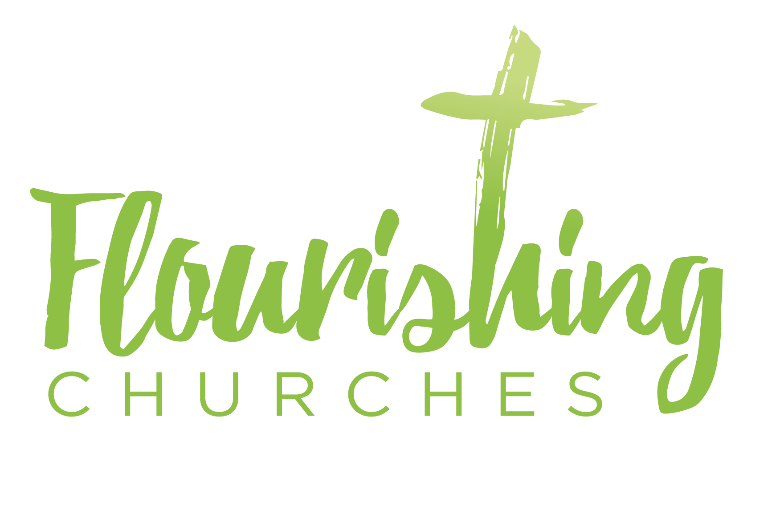

Sunday 26th July 2020: Trinity 7 Matthew 13 v31-33, 44-52

Welcome to Praying Together but Separately

Gathering Before God

Make sure you are sitting comfortably.

I am in the presence of the Living God, Father, and of the Son, and of the Holy Spirit. Amen.

Prayer of the Day

Holy Spirit
Dwell in me,
That I may become prayer.

Whether I sleep or wake,
Eat or drink,
Labour or rest,
May the fragrance of prayer
Rise, without effort in my heart.

Purify my soul and never leave me,
So that the movements of my heart and mind
May, with voices full of sweetness,
Sing in secret to God.
After St. Isaac the Syrian (seventh century)

Reflection

Breathe slowly and deeply.
Ask God to speak to you through the passage that you are about to read.

Bible Reading: Matthew 13 v31-33, 44-52

He put before them another parable: “The kingdom of heaven is like a mustard seed that someone took and sowed in his field; it is the smallest of all the seeds, but when it has grown it is the greatest of shrubs and becomes a tree, so that the birds of the air come and make nests in its branches.”
He told them another parable: “The kingdom of heaven is like yeast that a woman took and mixed in with three measures of flour until all of it was leavened.”
…
“The kingdom of heaven is like treasure hidden in a field, which someone found and hid; then in his joy he goes and sells all that he has and buys that field.”
“Again, the kingdom of heaven is like a merchant in search of fine pearls; on finding one pearl of great value, he went and sold all that he had and bought it.”
“Again, the kingdom of heaven is like a net that was thrown into the sea and caught fish of every kind; when it was full, they drew it ashore, sat down, and put the good into baskets but threw out the bad. So it will be at the end of the age. The angels will come out and separate the evil from the righteous and throw them into the furnace of fire, where there will be weeping and gnashing of teeth.”

“Have you understood all this?” They answered, “Yes.” And he said to them, “Therefore every scribe who has been trained for the kingdom of heaven is like the master of a household who brings out of his treasure what is new and what is old.”

Some thoughts for further Reflection:

Five metaphors are used to explain what the Kingdom of Heaven is like, list the five specific things used to represent the kingdom in each story and think about what role each one has in its own parable.
The kingdom of God is like:
- …....................................
- …....................................
- …....................................
- …....................................
- …....................................
What sort of Kingdom was Jesus talking about? We might normally think that the appeal is focused towards our religious beliefs and convictions, that being of ‘heaven’ bears little relevance to our day to day lives here and now. However, in Jesus’ time his words would have been understood to be drastically more important. It would have been ridiculous to suggest to the original hearers that religion and politics should be kept separate. To hear the weight of controversy more accurately, imagine Jesus is saying ‘the Nation of God’. Heaven has invaded earth through God’s work in Jesus and these parables are showing that gaining citizenship can cost everything we have, but is still thoroughly worthwhile.

Matthew uses his gospel to present an invitation to gain this citizenship for all his readers. He inhabits the scholar’s calling of verse 52, showing that Jesus’ life in these stories and the ongoing commission of disciples are fulfilling the purposes of God throughout history and the Hebrew Scriptures. Jesus leads no armies, writes no books nor builds any monuments, yet initiates a remarkable new Kingdom. This Kingdom’s values are outlined in the Sermon on the Mount (Matthew 5v1-7v27), faith orientated, radical love opposing possessive and aggressive traits humanity gravitates to. In our passage, different parables (metaphorical stories) are used to teach about how this transforming, loving faith will grow amongst humanity.

The five metaphorical representations of the Kingdom are not identical, and are understood best in contrast to each other. In the first story the kingdom is a plant that grows itself, clearly distinctive even from the soil it grows from and the birds that come to it. In the second though, the kingdom is an ingredient in the recipe of something bigger, a key element in the growing of that bigger thing but nothing like as distinct as the plant is. In one story the Kingdom is a treasure to be found by a person, yet in the next the Kingdom is the person themself rather than the object of great value that the person is seeking. These four stories act like two contrary pairs, giving ambiguity to precise definitions but focusing on the shared qualities that the Kingdom is growing and holds value. The Kingdom is something the reader should be seeking yet be aware that it is also seeking us out!

The final parable likens the Kingdom to a net that would be dragged along behind a fishing boat, catching fish and whatever else was in the water as the boat is moved by the wind. In this the Kingdom appears functional, for once the boat pulls it in, the job of the net is over. Only some of the fish are held as valuable. The kingdom’s final value then, is only understood because it is bringing people to God, and not everyone who is caught is ultimately accepted. That is a challenging message indeed.

“Many will say to Me on that day, ‘Lord, Lord, did we not prophesy in Your name, and in Your name cast out demons, and in Your name perform many miracles?’ And then I will declare to them, ‘I never knew you; depart from me, you who practice lawlessness.’ The dragnet parable reminds the reader of this closing challenge in the Sermon on the Mount. Membership of the Kingdom, even with great spiritual power, is not enough to guarantee full union with God. For us, membership of church communities is important and profitable to faith but ultimately not as important as our own relationships with Christ. The dragnet judgement is represented in Christ’s passion, for in Gethsemane all his friends abandoned him. Judas gave him up for money. Peter denied association with Jesus three times. Both Judas and Peter went away and mourned their betrayals but only Peter chose repentance and reconciliation. May God give us grace that when we are failing, for we all do, we authentically turn back to God with our whole being in prayer and seek reconciliation with those we may have hurt. Perhaps the question that can frame the challenge of this gospel, beyond a desire to be in the Kingdom, is to ask: are we actively seeking to be known by the King?

If we only seek to be in the Kingdom but neglect relationship with the King, we will only hold to the appearance of values. We will be generous, but not to the point of sacrificial giving that might change our lifestyle. We will be joyful but based more on our current circumstance than our eternal identity found in God. We will be imaginative, if new ideas do not stop the styles and patterns that we prefer. We will courageous, as long as we have insurance that covers the risk of loss.

Let us not lose heart, for God showed his love for us in providing His Son for us (Romans 8v32), if we want to put God first, He will accompany us by His Spirit. He is merciful with our mistakes because he is so very invested in finding us and bringing us into full life.

Creative Prayer activity for at home

This prayer time will try to help you make commitments to know King Jesus yourself. Think of and note down three different activities you can do this week to try to hear God’s Word through His Spirit. It could be studying a gospel chapter from the comfort of an armchair, praying on your knees for ten minutes before you go to bed, or going on a walk in one of your favourite beauty spots. Pray now for guidance for ideas and make commitments about when you will seek Him further.

- ….................................................................................................
- ….................................................................................................
- ….................................................................................................

The important things are to plan where and when these activities will take place, and to be able to still your mind to give the Holy Spirit time to give you a sense of peace. He may even speak to you through a memory, a verse or inspiring your imagination. If you sense God is saying something to you, why not share it with a prayerful and wise friend for their thoughts?

OUR PRAYERS
Let us pray using this ancient Byzantine Litany,

For the peace of the world, that a spirit of respect and forbearance may grow among nations and peoples, let us pray to the Lord.
Lord, have mercy.

For the holy Church of God, that it may be filled with truth and love and be found without fault at the day of your coming, let us pray to the Lord.
Lord, have mercy.

For those in positions of public trust, that they may serve justice and promote the dignity and freedom of all people, let us pray to the Lord.
Lord, have mercy.

For a blessing upon the labours of all, and for the right use of the riches of creation, let us pray to the Lord.
Lord, have mercy.

For the poor, the persecuted, the sick, and all who suffer; for refugees, prisoners, and all who are in danger, that they may be relieved and protected, let us pray to the Lord.
Lord, have mercy.

For this community; for those who are present, and for those who are absent, that we may be delivered from hardness of heart and show forth your glory in all that we do, let us pray to the Lord.
Lord, have mercy.

For our enemies and those who wish us harm; and for all whom we have injured or offended, let us pray to the Lord.
Lord, have mercy.

For all who have died in the faith of Christ, that, with all the saints they may have rest in that place where there is no pain or grief, but life eternal, let us pray to the Lord.
Lord, have mercy.

A prayer concerning the Coronavirus
God of compassion,
be close to those who are ill, afraid or in isolation.
In their loneliness, be their consolation;
in their anxiety, be their hope;
in their darkness, be their light;
through him who suffered alone on the cross,
but reigns with you in glory, Jesus Christ our Lord.
Amen.

An act of spiritual Communion
My Jesus,
I believe that You
are present in the Most Holy Sacrament.
I love You above all things,
and I desire to receive You into my soul.
Since I cannot at this moment
receive You sacramentally,
come at least spiritually into my heart.
I embrace You as if You were already there and unite myself wholly to You. Never permit me to be separated from You.
Amen.

The Lord’s Prayer
Our Father, who art in heaven, hallowed be thy name;
thy kingdom come; thy will be done;
on earth as it is in heaven.
Give us this day our daily bread.
And forgive us our trespasses,
as we forgive those who trespass against us.
And lead us not into temptation; but deliver us from evil.
For thine is the kingdom,
the power and the glory, for ever and ever. Amen.

