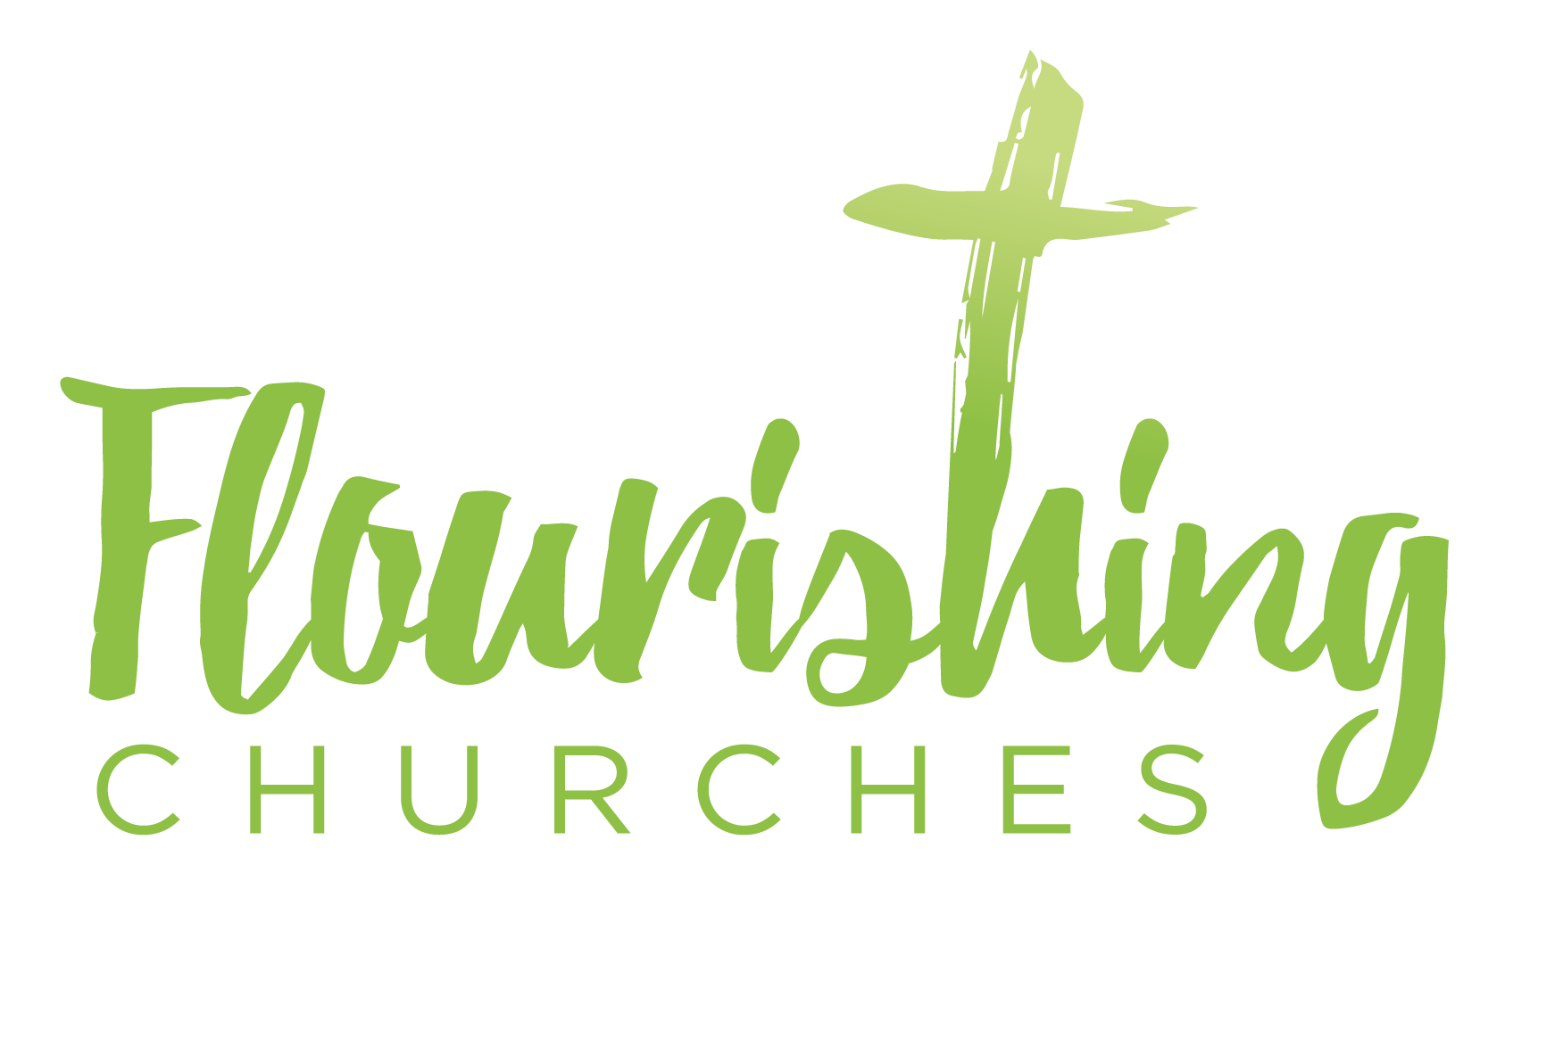
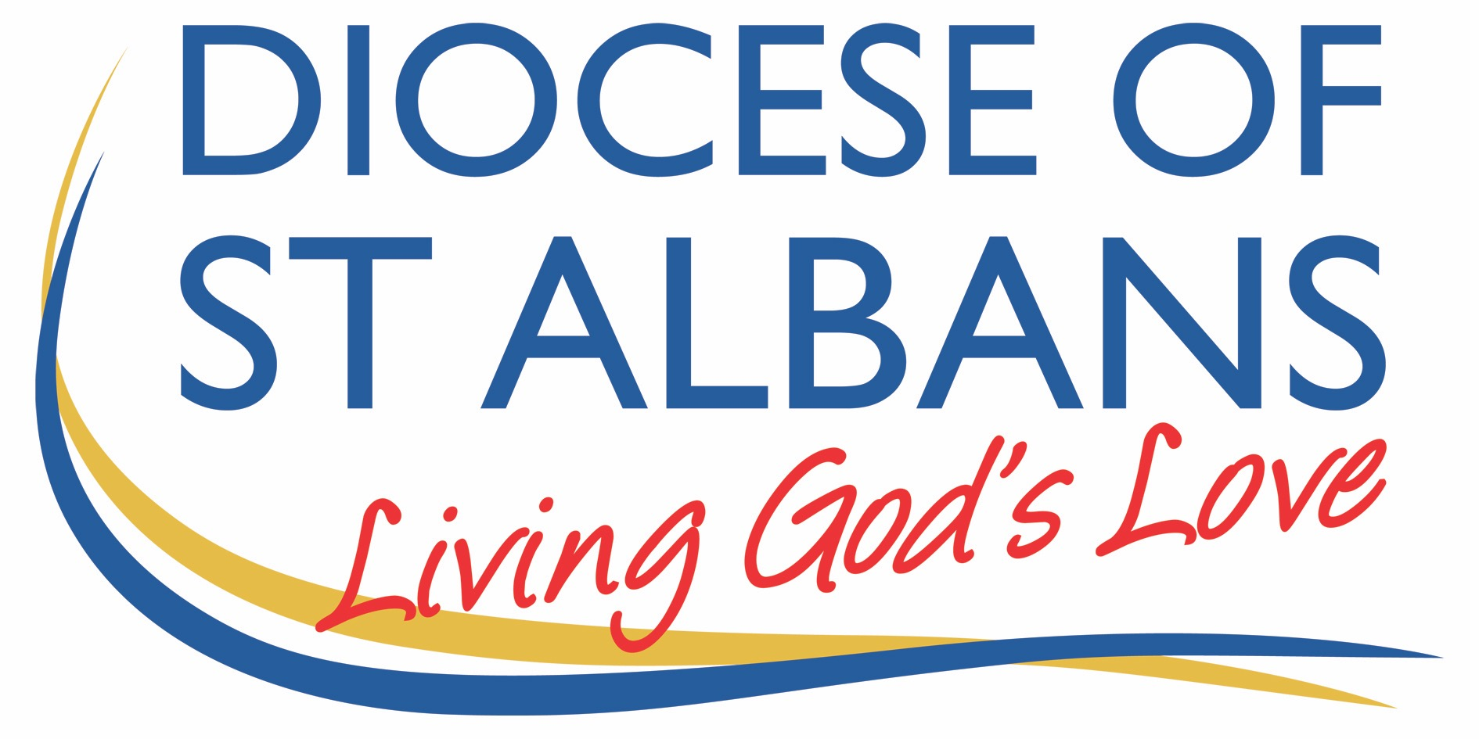

Sunday June 7th ~ Trinity Sunday: Matthew 28.16-20

Welcome to Praying Together but Separately

Gathering Before God

Make sure you are sitting comfortably.

I am in the presence of the Living God, Father, and of the Son, and of the Holy Spirit. Amen.

Prayer of the Day
Holy God,
Faithful and unchanging,
Enlarge our minds with the knowledge of your truth ,
and draw us more deeply into the mystery of your love,
That we may truly worship you,
Father, Son and Holy Spirit,
one God, now and forever. Amen.

Reflection

Breathe slowly and deeply.
Ask God to speak to you through the passage that you are about to read.

Bible Reading:

Matthew 28:16-20

The eleven disciples went to Galilee, to the mountain where Jesus had told them to go. When they saw him, they worshiped him; but some doubted. Then Jesus came to them and said, “All authority in heaven and on earth has been given to me. Therefore go and make disciples of all nations, baptizing them in the name of the Father and of the Son and of the Holy Spirit, and teaching them to obey everything I have commanded you. And surely I am with you always, to the very end of the age.”

Read through the passage once. Read it quietly out loud but say each word out loud.
Try and take note of any words or phrases that strike you.
Say that word or phrase quietly out loud or underline it with a pen.
Read the passage a second time.
As you read, think about how the word or phrase you notice might speak to you today.
After you have read the passage again, sit in silence and try and come up with a sentence or two that sums up what you think the word or phrase means for you today.

Read the passage a third time and prayerfully think about what Christ has said to you.

Some thoughts for further Reflection

In the life of a Christian over the centuries, when it comes to prayer and speaking to others about God, people choose through temperament to speak of and to God with different names.
For instance, some address God with words such as, God, Father, Jesus, Holy Trinity, Christ, Holy Spirit. It is often true, when people speak of God in terms of what they think or feel God is like, there is a reference to one of the persons of the trinity, for example when we say, “Our Father who art in heaven” or when we end a prayer with the words, “In the name of Jesus Christ” .
Trinity Sunday does not follow the Feast of Pentecost by accident. Trinity Sunday could not come before Pentecost because it is only with the coming of the Spirit that God is revealed in the heart of the disciples as Father, Son and Holy Spirt, which is why St Matthew’s Gospel draws to its close with these words, “Therefore go and make disciples of all nations, baptizing them in the name of the Father and of the Son and of the Holy Spirit”.
It also true that it took the Church many years to draw out and understand the meaning of this revelation concerning the Trinity.
As we learn from the Scriptures and the Church who God is and how we are to live a good life with God and the creation there is one golden truth that needs to be affirmed on this day above all days.
The Truth is this; whatever our hearts see and hear Jesus doing in the Gospel we are seeing and hearing the words and actions of God.
The Truth is not only that the Son of God is revealed in the words and actions of Jesus - we are seeing also the words and the actions of the Father and the Holy Spirit because God is One at all times.
The life of God within each of us is the One life of the Father, the Son and the Holy Spirit who moves us to live our life in communion with the One God, Father, Son and Holy Spirit, and with each other so that Thy Kingdom will Come !

Creative Prayer activity
Bring the index finger and the middle finger together with the thumb.
Close the other two fingers into the palm of your hand.
The three fingers touching are a symbol of the Trinity.
The thumb and the index finger together are a symbol of the divine nature of the One being made one with human nature through the Incarnation.
Ponder from time to time today the mystery of God as you make this symbol with your hand and then pray with this one question.
“How do I want my life to live with and within the Trinity today, what difference do I want to experience?”.

OUR PRAYERS
Loving God, we thank you that you give yourself to us in three ways;
Father, Son, and Spirit.
Thank you for being the One who made us and said that we are good.
Thank you for being the One who loves us, our Lord Jesus Christ.
Thank you for being the One who helps us become the people you want us to be.
Holy Spirit, soften our hearts today to love you more and help us to understand your wisdom. Lord in your mercy, Hear our prayer.

Generous God, we bless you and thank you as your Church for showing us who you are in the Word made flesh revealed to us in the pages of the scriptures and the life of the Church.
Open our minds and hearts as you have opened the scriptures, encouraging us to share your Good News with those who feel distant from your love today.
Lord in your mercy, Hear our prayer.

Holy One, You are the One who cherishes and upholds the whole earth and all that there is.
Come with wisdom and generosity into the hearts of the leaders of all the nations and with all who are seeking to find a vaccination and cure for the virus.
We pray for the world over, for all who are using your gift of life and skill to help the suffering.
For renewed strength and hope in the world today we pray.
Lord in your mercy, Hear our prayer.

Father, Son and Holy Spirit,
We bless you for setting us in our local community,
particularly for those who are closest to us,
and we pray for the needs of our community and our families near and far now in the silent moments of our hearts.
Lord in your mercy, Hear our prayer.

We pray for ourselves, asking that our lives may become full of the harmony and power of the Trinity, so our joy in you may flow, bringing people to share your Life, Father, Son and Holy Spirit. Lord in your mercy, Hear our prayer.

A prayer concerning the Coronavirus
Keep watch, dear Lord,
With those who wake, or watch, or weep this day.
Tend the sick,
Give rest to the weary,
Sustain the dying,
Calm the suffering
Pity the distressed
All for your love’s sake,
O Christ our Redeemer Amen.

An act of spiritual Communion
My Jesus,
I believe that You
are present in the Most Holy Sacrament.
I love You above all things,
and I desire to receive You into my soul.
Since I cannot at this moment
receive You sacramentally,
come at least spiritually into my heart.
I embrace You as if You were already there and unite myself wholly to You. Never permit me to be separated from You.
Amen.

The Lord’s Prayer
Our Father, who art in heaven, hallowed be thy name;
thy kingdom come; thy will be done;
on earth as it is in heaven.
Give us this day our daily bread.
And forgive us our trespasses,
as we forgive those who trespass against us.
And lead us not into temptation; but deliver us from evil.
For thine is the kingdom,
the power and the glory, for ever and ever. Amen.

