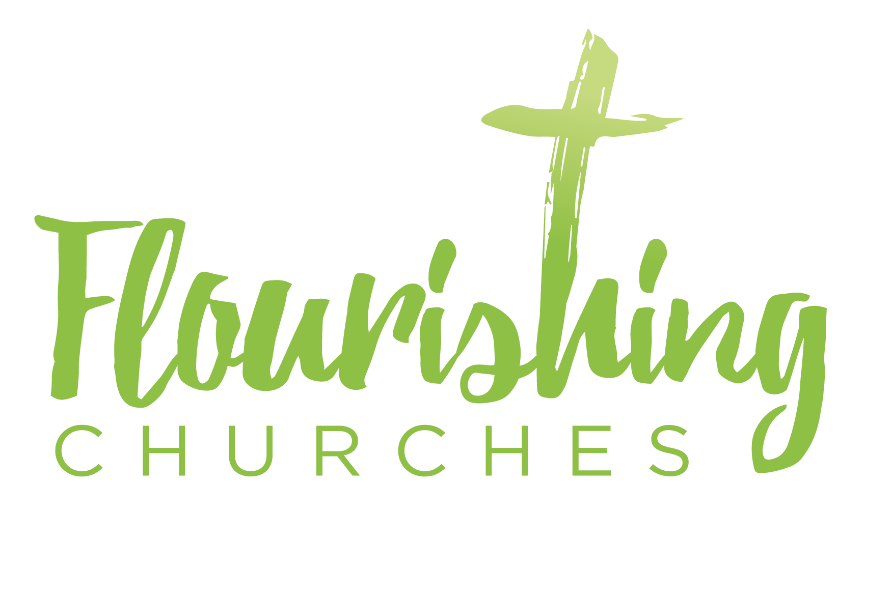
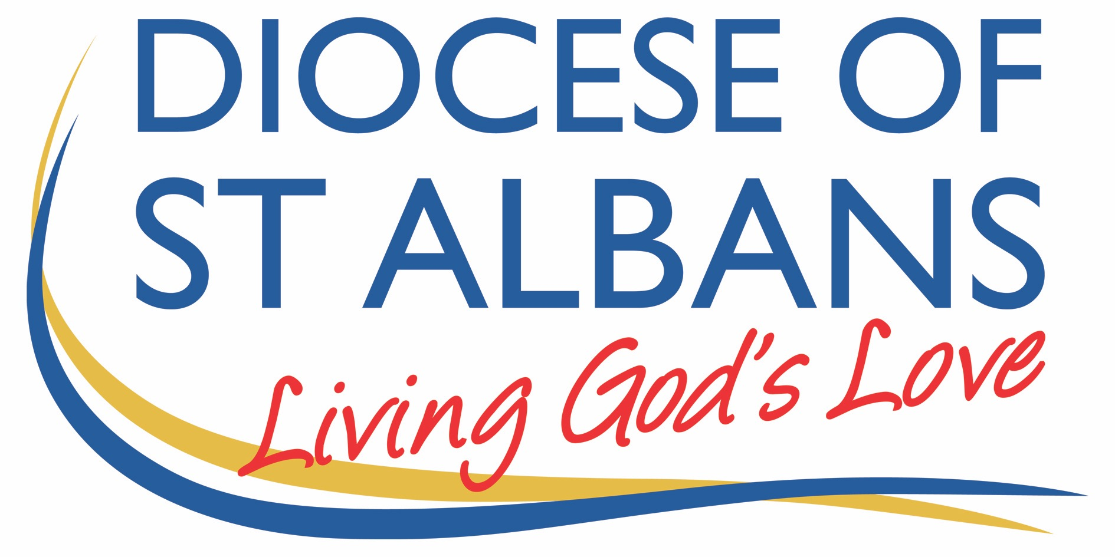

21st June 2020 – Trinity 2

Welcome to Praying Together but Separately

Gathering Before God

Make sure you are sitting comfortably.

I am in the presence of the Living God, Father, and of the Son, and of the Holy Spirit. Amen.

Prayer of the Day
Faithful Creator,
whose mercy never fails:
deepen our faithfulness to you
and to your living Word,
Jesus Christ our Lord. Amen.

Reflection

Breathe slowly and deeply.
Ask God to speak to you through the passage that you are about to read.

Bible Reading:
Matthew 10 v24-39

‘A disciple is not above the teacher, nor a slave above the master; it is enough for the disciple to be like the teacher, and the slave like the master. If they have called the master of the house Beelzebul, how much more will they malign those of his household!
‘So have no fear of them; for nothing is covered up that will not be uncovered, and nothing secret that will not become known. What I say to you in the dark, tell in the light; and what you hear whispered, proclaim from the housetops. Do not fear those who kill the body but cannot kill the soul; rather fear him who can destroy both soul and body in hell. Are not two sparrows sold for a penny? Yet not one of them will fall to the ground unperceived by your Father.
And even the hairs of your head are all counted. So do not be afraid; you are of more value than many sparrows.
‘Everyone therefore who acknowledges me before others, I also will acknowledge before my Father in heaven; but whoever denies me before others, I also will deny before my Father in heaven.
‘Do not think that I have come to bring peace to the earth; I have not come to bring peace, but a sword.
For I have come to set a man against his father,
and a daughter against her mother,
and a daughter-in-law against her mother-in-law;
and one’s foes will be members of one’s own household.
Whoever loves father or mother more than me is not worthy of me; and whoever loves son or daughter more than me is not worthy of me; and whoever does not take up the cross and follow me is not worthy of me. Those who find their life will lose it, and those who lose their life for my sake will find it’.

Read through the passage once. Read it quietly out loud but say each word out loud. Try and take note of any words or phrases that strike you, unsettle you or cause you to question. Say that word or phrase quietly out loud or underline it with a pen.

Read the passage a second time.
As you read, think about how the word or phrase you notice might speak to you today. After you have read the passage again, sit in silence and try and come up with a sentence or two that sums up what you think the word or phrase means for you today.

Read the passage a third time and prayerfully think about what Christ has said to you.

Some thoughts for further Reflection – by Kate Peacock

This is the sort of Gospel reading that tempts a vicar to rota on a visiting cleric or reader; it is perhaps one of the most demanding Gospel readings of the whole church’s year. If you underlined your passage above, I am guessing there are many lines and exclamation points. So let’s take a deep breath and dive in:

Do not think that I have come to bring peace to the earth; I have not come to bring peace, but a sword. For I have come to set a man against his father, and a daughter against her mother, and a daughter-in-law against her mother-in-law; and one’s foes will be members of one’s own household.

Whoever loves father or mother more than me is not worthy of me; and whoever loves son or daughter more than me is not worthy of me.

Well, I love my two children, my husband, my family. I love my Mother and my mother-in-law. Today I am left with a deep challenge – ours is a Gospel of both comfort and challenge. I delight in the words that God knows me and even the hairs of my head are counted; what joy and love is seen and experienced through that faith. Despite the other 6 billion people on this earth all of whom are children of God; I am known and loved; intimately and carefully; given value and worth. And so are you. What comfort to each of us to hear that!

But what of this notion of a hierarchy of love – who do you love more? Family or God? Well I for one love my two daughters more than I can say. I love God too – how can I love one more than other, how can I hear these words without feeling that I am going to fall short somewhere and that by putting my loved ones, including God into some kind of pecking order will hurt, offend and upset if not God then my family. When reading this our hearts can break as we seek to fathom what is being asked of us.

So as we begin with the challenge of this Gospel and to begin to grapple with this text we look first to our history. Jesus was not the first to say these words – he is quoting Micah an early prophet who was writing around 787-696 BC. Micah was writing at a time of huge political disruption where the threat came from the north – from Babylon where the army were threatening and eventually in 587BC destroyed Jerusalem and the temple that was built by King Solomon. Micah prophesized saying that families would be divided as some were idolatress and some were faithful to YHWH. Micah was right – God spoke through him to warn the people of the impending destruction, but they didn’t listen and continued to turn away from God and put their trust in false Gods.

Jesus is saying that his message will also divide families – in his day Israel was turning away from God and it is fair to suggest that Jesus is issuing the first warning about the destruction of the temple – just as Micah did – but Jesus is talking of himself.

Jesus knows that the destruction of his body, the temple will cause division – even within households. Micah, and Jesus in quoting him was not wrong. Division is easy to see all around us.

Yet, as children of God we are called to be one family – our Baptisms make us members of the worldwide family of the church. It is said that in church, water is thicker than blood. The water of baptism thicker than the blood of our ancestors and forebears. We, whether we know each other or not are family – adopted brothers and sisters of the same heavenly Father. This is our primary calling and today we are challenged in our Gospel to love God more than our own flesh and blood. And yet as I speak these words they feel controversial, dangerous even.

God is our Father, yes that is how we pray. Abba, Father. But can we seriously ask ourselves if our love for God is greater than our love for our earthly families.
Every parent, every Godparent, every Grandparent, Aunt or Uncle knows the love of a child, to have children in our lives makes our hearts grow bigger than we could imagine. And to love our parents is our joy too – my Mum facetimes regularly to see how we’re faring in lockdown!

Do I love God more? That is the heart of the question? And it’s tough.

For me the answer can only be reached through a better understanding of love itself. I am reminded in all this of the first letter of John – God is love and those who live in love live in God and God lives in them. We say this as the first words in every marriage ceremony. God is Love. So if I love my two daughters I am only loving them because God is love. I can only love because God dwells in me and I in him. I can only love because that is the gift of God.

So instead of an hierarchy of finite love – I think instead of a gift, a multiplying and gracious gift – which the more you use the more you have.

Without God I cannot love. Without God there is no love.

So who do I love the most? It’s the wrong question – ONLY by accepting the love of God in my heart can I begin to love others or even myself. Only by God being God can I be a parent or a child to my family – my immediate family and God’s family of the church. Only by God loving us can we love each other.

So through God’s love I love and receive love.

And that is the burning word of God that we are called not to keep in and contain, but rather to tell the world – praise the Lord, God is love. God knows the hairs of our heads and we are made in his image.

Creative Prayer Idea
Draw a large heart on a piece of paper. Inside write the names of those you love; your children, neighbours friends; use initials if you need space. Pray for them. Pray for those especially who do not yet know the love of Christ.

Imagine that you can only draw that heart because of God; you can only love those people because God is love. The line of the heart is God’s embrace. Pray that you and they may know God’s loving embrace this day.

A prayer concerning the Coronavirus
Keep watch, dear Lord,
With those who wake, or watch, or weep this day.
Tend the sick,
Give rest to the weary,
Sustain the dying,
Calm the suffering
Pity the distressed
All for your love’s sake,
O Christ our Redeemer Amen.

An act of spiritual Communion
My Jesus,
I believe that You
are present in the Most Holy Sacrament.
I love You above all things,
and I desire to receive You into my soul.
Since I cannot at this moment
receive You sacramentally,
come at least spiritually into my heart.
I embrace You as if You were already there and unite myself wholly to You. Never permit me to be separated from You. Amen.

The Lord’s Prayer
Our Father, who art in heaven, hallowed be thy name;
thy kingdom come; thy will be done;
on earth as it is in heaven.
Give us this day our daily bread.
And forgive us our trespasses, as we forgive those who trespass against us.
And lead us not into temptation; but deliver us from evil.
For thine is the kingdom,
the power and the glory, for ever and ever. Amen.

