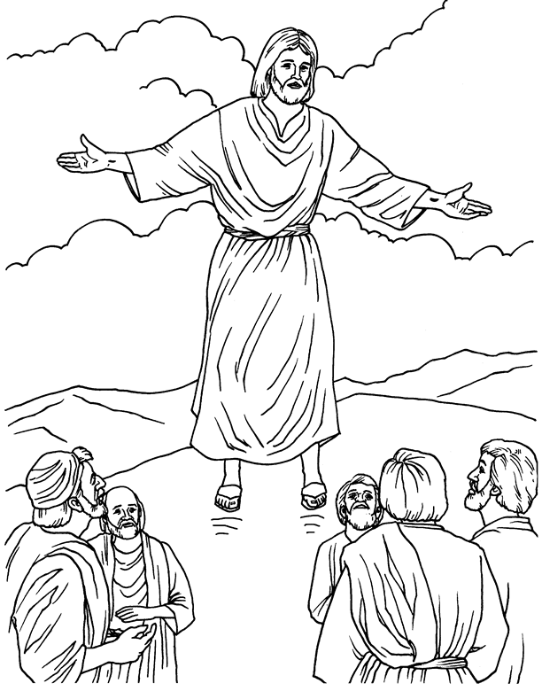

Copyright © 2001 - 2020. Sermon4Kids. All Rights Reserved

