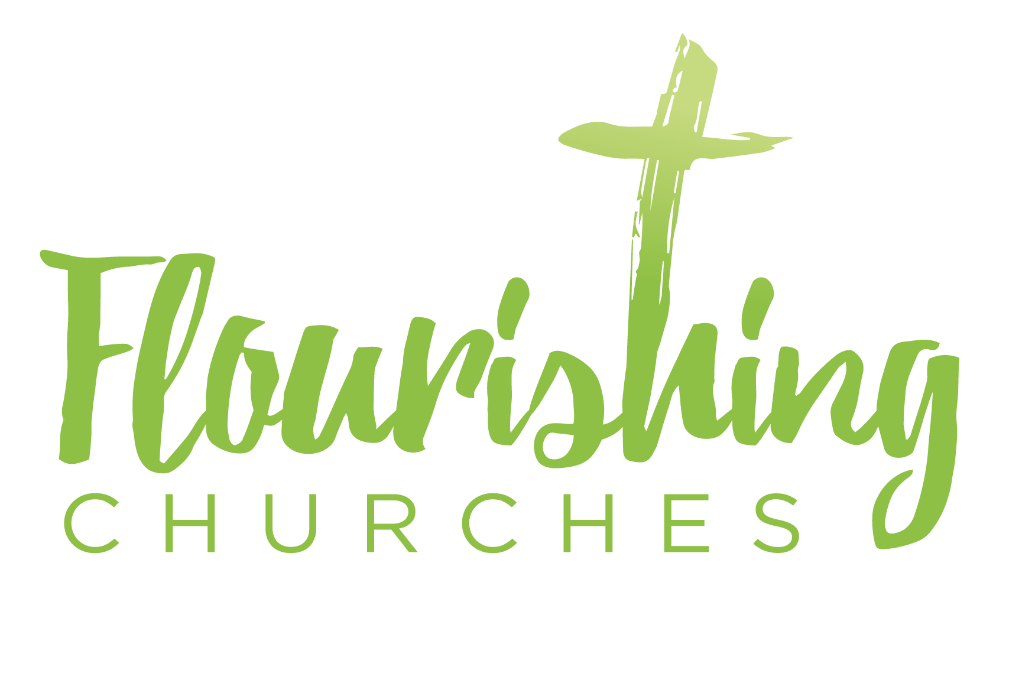
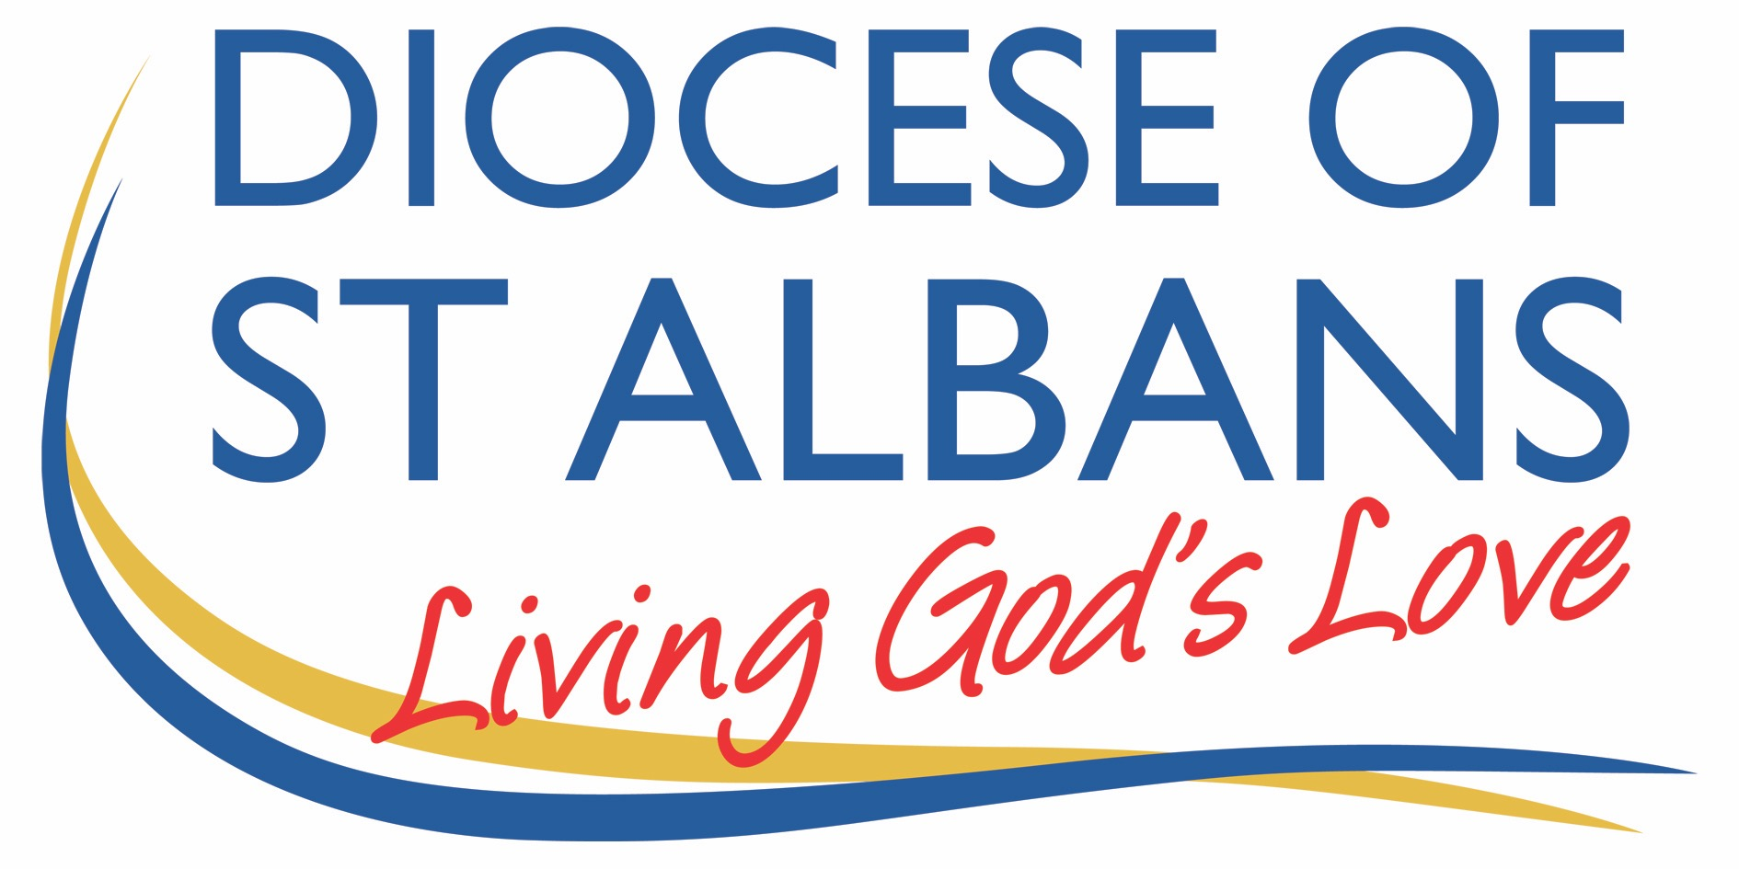

Easter Four- 3rd May 2020

How to use these prayers

Please work through the prayers at your own pace. It may take you thirty minutes it may only take five. You may like to watch and listen to your favourite Hymns.

Gathering Before God

Make sure you are sitting comfortably. Light a candle if you have one; any candle will do.

Breathe slowly and deeply.

I am in the presence of the Living God, Father, and of the Son, and of the Holy Spirit. Amen.

Prayer of the Day
Risen Christ,
faithful shepherd of your Father’s sheep:
teach us to hear your voice
and to follow your command,
that all your people may be gathered into one flock,
to the glory of God the Father.

Bible Readings: Acts 2.42-47 and John 10.1-10

Breathe slowly and deeply.

Ask God to speak to you through the passage that you are about to read.

Reflection on John 10.1-10:

The image that Jesus uses in the Gospel reading for today – that of a shepherd whose sheep recognise the shepherd’s voice – would have been very familiar to those who originally heard Jesus.

Coming from Sheffield as I do, most villages in and around the Peak District will have a road called ‘Pinfold Lane’. A ‘pinfold’ is the northern term for a common area shared by all the village where stray sheep were enclosed until their shepherd claimed them (I believe in the south such places are more commonly known as a ‘pound’). In the Middle East flocks of sheep were often mixed up together in safe places and kept there overnight where the shepherds could easily keep an eye on them and keep wild animals out. In this way sheep were frequently herded in to caves or some other safe enclosure, with sheep from different herds that belonged to different shepherds all muddling together. In the morning the different shepherds would call out, and from the common safe place, the different sheep would recognise the call of their shepherd and follow, whilst ignoring the call of shepherds they didn’t know.

This common sight of sheep recognising the voice of their own shepherd, and of sheep being led away from danger and toward abundant pasture, was therefore a familiar scene, and one that had been alluded to in the past by the prophets of Israel. With this picture in the minds of his hearers, Jesus talked about the ‘abundant life’ he had come to bring: safe places, rich pasture, and sheep knowing the call of their shepherd. It is a picture of knowing, being close to, and recognising the voice of the one who has responsibility for us: the one who is called to keep us safe and fed.

Jesus’ ‘abundant life’ has allusions of the Hebrew concept of shalom. Shalom is normally translated into English as ‘peace’ but means much more than just the absence of strife and conflict. Shalom means wholeness, wellbeing, health, happiness, and security: a full and abundant life in fact. All of these are ideas which seem a long way away from our current reality.

We have a shepherd who calls our name, who keeps us safe, who leads us to rich pasture: so why are things so difficult at this time? Or to put that question in a different way, expressed as one of the most common theological questions, and that currently feels very real to us: why does a loving God allow suffering?

In today’s reading Jesus tells us that he has come to bring abundant life, and that it is the ‘thief’ who comes to ‘steal, kill and destroy’.

The question of suffering and who is responsible for that suffering was very eloquently expressed by a country music songwriter in a song about the Dust Bowl period of 1930s America - a song, in fact, about much more than that period of history:

How much of this was meant to be?
How much the work of the devil?
How far can one man’s eyes really see,
in these days of toil and trouble?
How much of this is failing flesh?
How much a course of retribution…?
- Bill Mallonee and the Vigilantes of Love, “Resplendent” on the Album Audible Sigh

However we answer that question, if we have an answer at all, will depend on our theological viewpoint. What we can say with certainty is that suffering is a mystery.

The New Testament concept of mystery is not a problem that needs to be solved, or a question that needs an answer. Rather it is a reality that we cannot understand, but that we are invited to participate in, as it is a step on the road to salvation, redemption, restoration and eternity with God. (For example, see: Romans 5.3; 8.17-18; 2 Corinthians 1.5-7; Philippians 3.10; 1 Thessalonians 1.6; 2 Thessalonians 1.5; 2 Timothy 1.8-13; 2.3-9; and James 5.7-10).

The developed world is more insulated and insured against suffering than other parts of the world: so most of us are not very au fait with the mystery of suffering. In our own nation the fault lines of suffering match up to a great extent with the lines of poverty: it is often the poor who know more about suffering, and it certainly looks as if that is to be the case in this current crisis (thus recalling that other teaching of Jesus in Luke 6.20: ‘Blessed are the poor’). However necessary suffering may be (and there may be a difference between general suffering and suffering for the sake of the Gospel) it is something we hope and pray to avoid. Indeed, Jesus’ own ministry focussed on alleviating suffering in those he met: he was moved to perform many healings and miracles because he had compassion on those who suffered.

At times like this, in the face of suffering, what we need most is faith, hope, and love. Ultimately love wins because there is nothing – no suffering, not even death, and certainly not the ‘thief’ who is intent on killing, stealing and destroying – that can separate us from the love of God that is in Christ Jesus (Romans 8.38-39). May know deeply this truth that guides us through periods of suffering: nothing can separate us from the love of God. May it be the voice of the one true shepherd that calls to us, guides us, and keeps us safe. And may we show and share the knowledge of that love of God present with us in the midst of suffering with our neighbours and those we know. Amen.

Revd. Harry Steele
Creative Prayer Idea

On the outline of the shepherds crook, write or draw something you would like to see in your church. Pray and reflect how church might be different from how it was when we are allowed to gather together again for public worship. Consider what role you can play in being part of this prayer. Feel free to add more colour to your crook!

A prayer concerning the Coronavirus

Lord Jesus Christ,
you taught us to love our neighbour,
and to care for those in need
as if we were caring for you.
In this time of anxiety, give us strength
to comfort the fearful, to tend the sick,
and to assure the isolated
of our love, and your love,
for your name’s sake.
From the Church of England website

An act of spiritual Communion

My Jesus,
I believe that You
are present in the Most Holy Sacrament.
I love You above all things,
and I desire to receive You into my soul.
Since I cannot at this moment
receive You sacramentally,
come at least spiritually into my heart. I embrace You as if You were already there and unite myself wholly to You. Never permit me to be separated from You.
Amen.
Taken from https://www.ewtn.com/catholicism/devotions/act-of-spiritual-communion-339

The Lord’s Prayer

Our Father, who art in heaven, hallowed be thy name;
thy kingdom come; thy will be done; on earth as it is in heaven. Give us this day our daily bread. And forgive us our trespasses, as we forgive those who trespass against us. And lead us not into temptation; but deliver us from evil. For thine is the kingdom, the power and the glory, for ever and ever. Amen.

With the power that raised Jesus from the dead at work within you,
go in peace to love and serve the Lord. Alleluia, alleluia.
In the name of Christ. Amen. Alleluia, alleluia.

