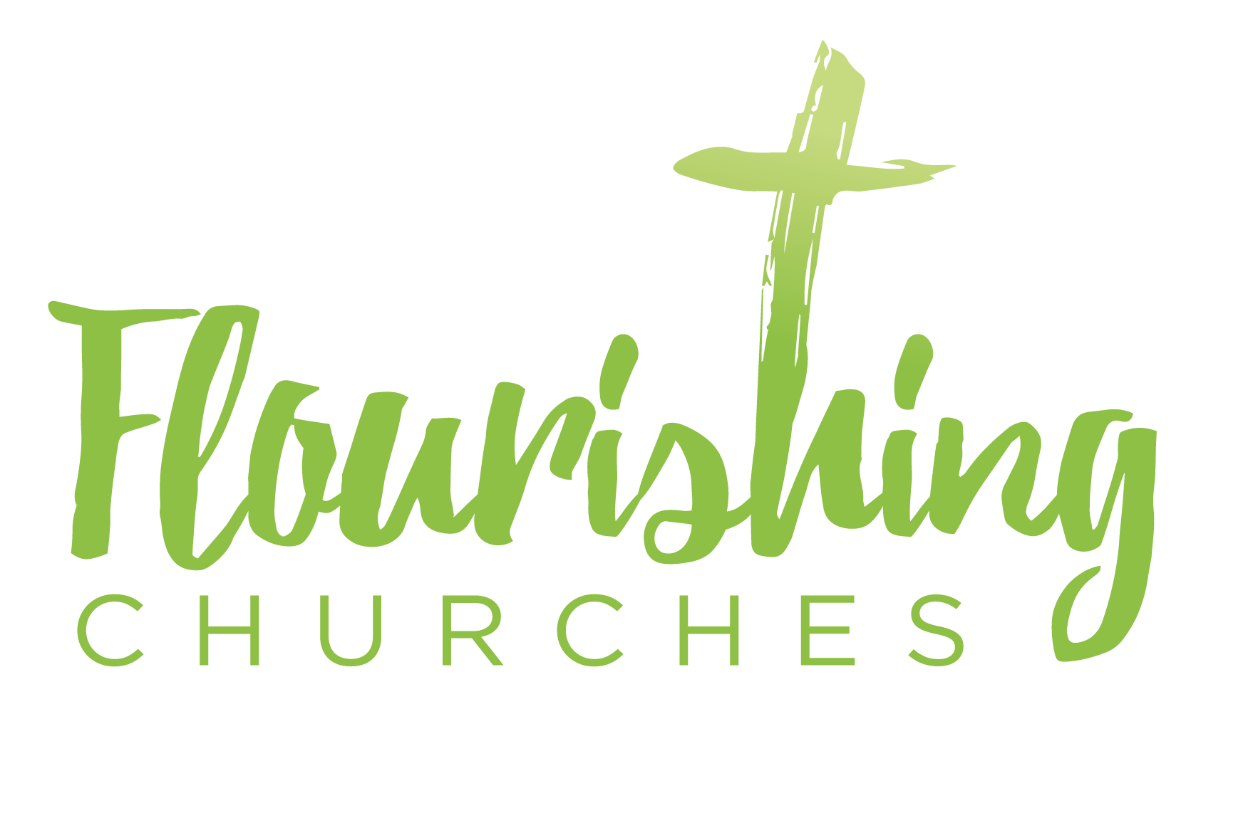
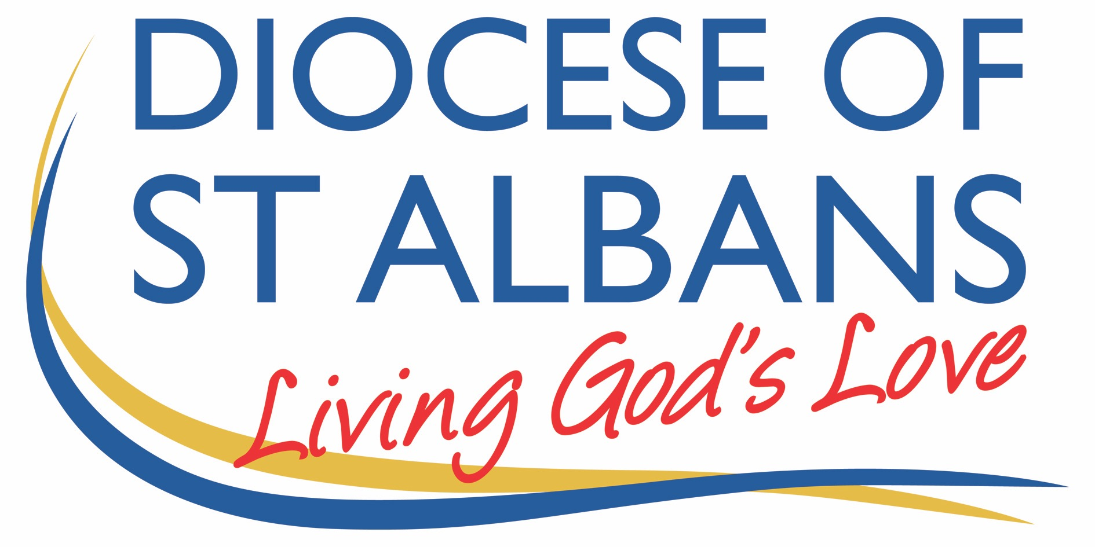

Sunday 31st May 2020 – Pentecost
Acts 2 v1-21 & John 7 v37-39

Welcome to Praying Together but Separately

Gathering Before God

Make sure you are sitting comfortably.

I am in the presence of the Living God, Father, and of the Son, and of the Holy Spirit. Amen.

Prayer of the Day
Holy Spirit, sent by the Father,
ignite in us your holy fire;
strengthen your children with the gift of faith,
revive your Church with the breath of love,
and renew the face of the earth,
through Jesus Christ our Lord. Amen.

Reflection

Make sure you are sitting comfortably.
Breathe slowly and deeply.
Ask God to speak to you through the passage that you are about to read.

Bible Readings:
Acts 2 v1-21
When the day of Pentecost had come, they were all together in one place. And suddenly from heaven there came a sound like the rush of a violent wind, and it filled the entire house where they were sitting. Divided tongues, as of fire, appeared among them, and a tongue rested on each of them. All of them were filled with the Holy Spirit and began to speak in other languages, as the Spirit gave them ability.
Now there were devout Jews from every nation under heaven living in Jerusalem. And at this sound the crowd gathered and was bewildered, because each one heard them speaking in the native language of each. Amazed and astonished, they asked, ‘Are not all these who are speaking Galileans? And how is it that we hear, each of us, in our own native language? Parthians, Medes, Elamites, and residents of Mesopotamia, Judea and Cappadocia, Pontus and Asia, Phrygia and Pamphylia, Egypt and the parts of Libya belonging to Cyrene, and visitors from Rome, both Jews and proselytes, Cretans and Arabs—in our own languages we hear them speaking about God’s deeds of power.’ All were amazed and perplexed, saying to one another, ‘What does this mean?’ But others sneered and said, ‘They are filled with new wine.’ But Peter, standing with the eleven, raised his voice and addressed them: ‘Men of Judea and all who live in Jerusalem, let this be known to you, and listen to what I say. Indeed, these are not drunk, as you suppose, for it is only nine o’clock in the morning. No, this is what was spoken through the prophet Joel:

“In the last days it will be, God declares, that I will pour out my Spirit upon all flesh,
and your sons and your daughters shall prophesy,
and your young men shall see visions, and your old men shall dream dreams.
Even upon my slaves, both men and women, in those days I will pour out my Spirit;
and they shall prophesy.
And I will show portents in the heaven above and signs on the earth below,
blood, and fire, and smoky mist.
The sun shall be turned to darkness and the moon to blood,
before the coming of the Lord’s great and glorious day.
Then everyone who calls on the name of the Lord shall be saved.”

John 7 v37-39
On the last day of the festival, the great day, while Jesus was standing there, he cried out, ‘Let anyone who is thirsty come to me, and let the one who believes in me drink. As the scripture has said, “Out of the believer’s heart shall flow rivers of living water.” ’ Now he said this about the Spirit, which believers in him were to receive; for as yet there was no Spirit, because Jesus was not yet glorified.

Reflection
The Holy Spirit the life giver the rush of wind, the flame of fire and refinement, the noise crashing through that upper room; that gushing up of living water. The dove from the heavens at Christ’s Baptism, that movement of wind over over the void and chaos in creation. The beating heart of the Trinity bringing healing and life, maternal perhaps and all about giving life. She is often called the Holy Comforter – and as we reflect, we know we need comfort most deeply in these days of illness, isolation and lockdown.
The HS remains a mystery at the heart of God; the cosmic divinity that cannot be contained by description or definition. So we look to where we can speak with authority and that for me comes from two places; theology and experience. Both it has to be said will fall short; words and metaphors, pictorial language and images will not do her full justice. Gender even I do not think does justice to this force, this power, this life of God. Beyond humanity, beyond creator, beyond incarnation, beyond our imaginations; BUT and most importantly for us – NOT beyond our experience.

Firstly then our Theology – that is where we look quite simply at what others have said of God. The ancient Church Fathers from Greece described and understood the Holy Spirit as the Divine Dance; the relationship between Father and Son, there at the beginning and given to us now. We are temples of this HS; this movement of God and Son, this dance of life. The trinity has at its heart a relationship – perfect and circular, dancing in harmony – and the dance is the Sprit. The relationship is the spirit. The love between father and son and us is the Spirit. The love and the dance is the spirit. I am the Lord of the Dance said he.

In the beginning was the word – In the beginning was the relationship; the dance, the love; we in our day and in our time are invited to join in; not as observers on the sidelines but as the center of that dance; at the beating heart of God. Through the HS we are invited into that relationship; we don’t look in from the outside; peering enviously through a window as at a party we’re not invited to; but we are center stage, we are invited to be prime movers in that relationship of love.

So we, as vessels of God’s Spirit are invited to take part; to enjoy fully and without boundaries that love that God has for us; that we cannot change; we can neither reduce or increase God’s love for us. That fire that rests on the heads of the disciples rests in us too; melting and moulding and dissolving boundaries and barriers; refining our very selves so we too are free to dance.

So what then of experience? How do we join in with the dance; especially when we are convinced we have two left feet?

Well; for me it comes in prayer. In prayer we dare to hear the voice of the HS – ‘you are my child the beloved with you I am well pleased’ – the words God said to Jesus at his Baptism he says to us too. In prayer we break down our own barriers, our own confession for all the stuff that gets in the way of the rhythm and the music and the motion of dance. The fear, the reluctance, the dancing to a different tune; our own tune not God’s. To know, to dare to believe we are forgiven is the most liberating feeling – we feel more ourselves. We feel lighter, freer, more integrated; less compromised. Undeserving maybe; but granted all the same. And because God forgives us we MUST forgive ourselves. This can be harder. We need the dance to carry us from one side of the room to the other; from sin and pain to light and music.

The HS calls us to this way of being; God in creation gave us ears to hear and hearts to love and eyes to see; the HS calls us to use them to God’s glory to see his hand and to dance to his tune. The only things that keep us out of this dance are doubt and fear. When we are free we dare to experience God, and for me, to describe that feeling of God is perfect. It is soaring on the wings, it is perspective and broad horizons, it is that small voice of invitation which says talk to me, know me. Knowing myself loved and held by his right hand. Knowing that despite my clumsy and failed efforts my dancing is raised to new heights and my life is elevated to divine standards – that is grace, that is comfort, that is love. And that my friends is the HS at work.

Know that perfect love that casts out all fear; the love of the Father, the love of the Son and know yourself invited into that deepest relationship – let the HS dwell in you like fire melting and dissolving all boundaries, and know the HS gushing up in you like living water- so that your thirst – your thirst for God and your thirst for knowing yourself is truly satisfied. And on this day; we rejoice in that love – and we know ourselves invited into the heart of that relationship.
Creative Prayer activity
Listen to your favourite piece of music – it can be any genre! Sit quietly and enjoy it; and then as you are able, dance to it. Sway softly to the rhythm. Tap your fingers in time. Nod your head as you keep the beat. Now know that God holds your hand as you move; God who created your body and your soul holds you and dances with you. His rhythm is your rhythm. His arms envelop you, and lead you from fear to hope, from darkness to light. This is God upon whom you can lean and from whom comes all comfort. Maybe wrap yourself in a blanket or duvet and feel safe and warm and remind yourself this is God’s will for you – safety and His comfort. Maybe do this tonight as you go to bed or when you wake up in the morning.

The Holy Spirit is also described as flames or fire. Maybe light a candle and just watch it dance in the air as drafts or wind cause it to sway. Try moving it with your breath; as you breathe out let go of your pain, guilt, fear (or whatever else you want to let go of) and watch the candle move - as you breathe in the candle rights itself and is restored to a full flame. Pray to know yourself fully restored to God’s image. Maybe pray that the Spirit in your heart is fanned to a full flame.

A prayer concerning the Coronavirus

Keep us, good Lord, under the shadow of your mercy.
Sustain and support the anxious, be with those who care for the sick,
and lift up all who are brought low;
that we may find comfort
knowing that nothing can separate us from your love
in Christ Jesus our Lord. Amen From the Church of England website

An act of spiritual Communion

Thanks be to you, Lord Jesus Christ, for all the benefits you have given me, for all the pains and insults you have borne for me. Since I cannot now receive you sacramentally, I ask you to come spiritually into my heart. O most merciful redeemer, friend and brother, may I know you more clearly, love you more dearly, and follow you more nearly, day by day. Amen.
after the Prayer of St Richard of Chichester

The Lord’s Prayer

Our Father, who art in heaven, hallowed be thy name;
thy kingdom come; thy will be done; on earth as it is in heaven. Give us this day our daily bread. And forgive us our trespasses, as we forgive those who trespass against us. And lead us not into temptation; but deliver us from evil. For thine is the kingdom, the power and the glory, for ever and ever. Amen.

