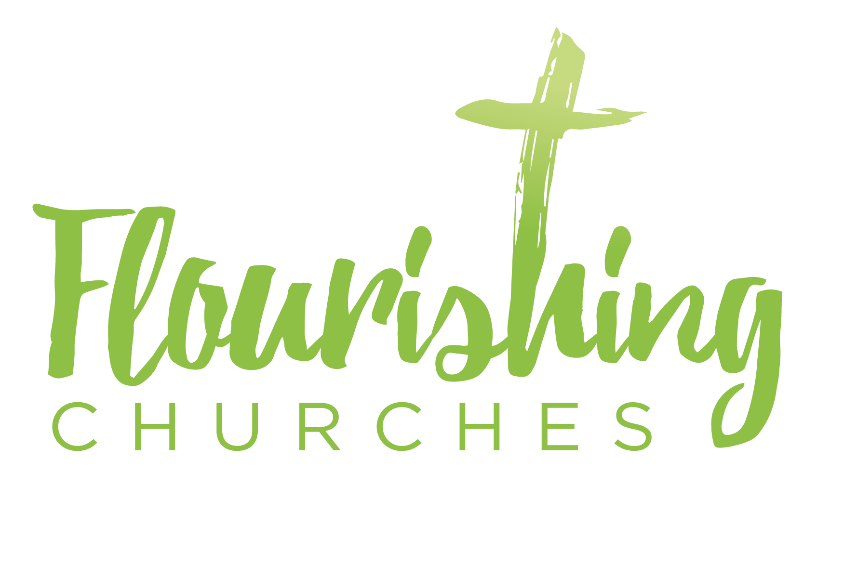

Sunday17th May: John 14 v15-27

Welcome to Praying Together but Separately

More prayers and ideas can be found here: https://www.churchofengland.org/more/media-centre/coronavirus-covid-19-liturgy-and-prayer-resources

Gathering Before God

Make sure you are sitting comfortably.

I am in the presence of the Living God, Father, and of the Son, and of the Holy Spirit. Amen.

Prayer of the Day
God our Father,
Whose Son Jesus Christ gives the water of eternal life:
May we thirst for you,
The spring of life and source of goodness,
Through him who is alive and reigns, now and for ever. Amen.

Reflection

Breathe slowly and deeply.
Ask God to speak to you through the passage that you are about to read.

Bible Readings:
John 14 v15-27
‘If you love me, you will keep my commandments. And I will ask the Father, and he will give you another Advocate, to be with you for ever.
This is the Spirit of truth, whom the world cannot receive, because it neither sees him nor knows him. You know him, because he abides with you, and he will be in you.
‘I will not leave you orphaned; I am coming to you. In a little while the world will no longer see me, but you will see me; because I live, you also will live. On that day you will know that I am in my Father, and you in me, and I in you. They who have my commandments and keep them are those who love me; and those who love me will be loved by my Father, and I will love them and reveal myself to them.’ Judas (not Iscariot) said to him, ‘Lord, how is it that you will reveal yourself to us, and not to the world?’ Jesus answered him, ‘Those who love me will keep my word, and my Father will love them, and we will come to them and make our home with them. Whoever does not love me does not keep my words; and the word that you hear is not mine, but is from the Father who sent me. ‘I have said these things to you while I am still with you. But the Advocate, the Holy Spirit, whom the Father will send in my name, will teach you everything, and remind you of all that I have said to you. Peace I leave with you; my peace I give to you. I do not give to you as the world gives. Do not let your hearts be troubled, and do not let them be afraid.

Read through the passage once. Read it quietly out loud but say each word out loud.
Try and take note of any words or phrases that strike you.
Say that word or phrase quietly out loud or underline it with a pen.

Read the passage a second time.
As you read, think about how the word or phrase you notice might speak to you today.
After you have read the passage again, sit in silence and try and come up with a sentence or two that sums up what you think the word or phrase means for you today.

Read the passage a third time and prayerfully think about what Christ has said to you.

Some thoughts for further Reflection

This Thursday, May 21, we will be celebrating the Feast of the Ascension (Jesus ascending to heaven to be reunited with his Heavenly Father) in our homes and then we wait to celebrate the Feast of Pentecost (the coming of the Holy Spirit as fire and gust of wind) the following Sunday. The passage we have just read is a part of what Bible scholars call the “Farewell discourses” chapters 13 -17 in John’s Gospel. Within these chapters the focus is on the last days of Jesus’ earthly life, and in particular the last meal Jesus had with his disciples the night before his crucifixion.
For the early church, and for us, the Farewell discourses summarise and make explicit Jesus’ teaching for his disciples. The words of John’s Gospel here are intense and full of hidden depths that can only be grasped sensitively and slowly.
Jesus, in the passage says, “I will not leave you orphaned; I am coming to you. In a little while the world will no longer see me, but you will see me; because I live, you also will.”
Jesus affirms the power of his Resurrection when he says, “Because I live, you also will.”
In fact for the disciples their new resurrected life has already begun with Jesus’ resurrection. They are now experiencing the truth of St Paul’s words when he says, ”O death where is thy sting? O grave, where is thy victory?”
Judas (not Iscariot) said to Jesus, ‘Lord, how is it that you will reveal yourself to us, and not to the world?”
What a great question, full of power and mystery, not only for the early church but for us today. In other words, how are we as disciples, going to see the Risen Jesus while everyone else does not?
Have there not been times in our own lives when we have asked ourselves and each other, ‘how is it that I have faith and experience God in my life and yet my friends, my family, the people I work with seem unable to see and experience the life of Jesus?’ So often I have asked and listened to this question along with Judas and the early church and yet for myself I have not often stopped and pondered on one of the answers that Jesus gives to this question himself. In the passage today Jesus says this,
“Those who love me will keep my word, and my Father will love them, and we will come to them and make our home with them.”
Simply put, perhaps it is only in seeking and wanting to see God through seeking to love (“the commandment”) can we come to experience and see the risen Jesus.

John, answers the possible next question, “So where do I need go to for Jesus to find me?” John replies in the words of Jesus, “We will come to them and make our home with them.” In other words, God is found and is revealed to us in the home of our hearts and then in the hearts of other disciples.
Teresa of Avila says this,
“Soul, you must seek yourself in Me and in yourself seek Me.”
In Matthew’s Gospel (Chapter 5) Jesus tells us that the Father’s love and kindness is for all and always when he says, “He makes his sun rise on the evil and on the good, and sends rain on the just and on the unjust.”
Yet those who want to see him need to seek and look within their own hearts so as to be found by Jesus.

Creative Prayer activity
Draw or make a small symbol of your heart, carry with it you or place it somewhere visible. Ponder from time to time as you remember that you have it with you and ask this one question.
“What do I want to see and find in my heart today?”

OUR PRAYERS
Risen Christ you are all and within all things,
You are the giver and the gift.
You love us without hesitation.
Help us always to recognize that you are the one who is in our hearts.
Do not let our hearts be troubled, and do not let them be afraid.
Lord in your mercy,
Hear our prayer.

Risen Christ, you take our troubled hearts and turn them from darkness to light.
With you we lose all our fear and find new hope,
New joy to begin again.
Take from us our blindness,
So to see you more clearly in the hours of this day.
Lord in your mercy,
Hear our prayer.

You, O Christ are the one whom we seek and who we find in our hearts.
You are the one who cherishes and upholds the whole world within our hearts.
Come with wisdom and generosity into the hearts of the leaders of all the nations and with all who are seeking to find a vaccination and cure for the virus.
We pray for the world over, for all who are using your gift of life and skill to help the suffering.
For renewed strength and hope in the world today we pray.
Lord in your mercy,
Hear our prayer.

O Christ, all life comes from you and is held and sustained by the breath of your Spirit.
For all who are sick and needy at this time we pray.
For those close to us and those who are far way.
Grant to those who are longing for health in body, mind and spirit today,
To be filled with the warmth of your Spirit and healing.
Lord in your mercy,
Hear our prayer.

For all whose gift of life and living has ended in death.
For all whose experience of living is now renewed and revealed on a more distant shore.
We pray for………
Grant to them O Christ, with us, the gift of peace and light.
You who give the starry night and the wonders of the deep,
who says, I am with you always even till the end of time.
Lord in your mercy,
Hear our prayer.

A prayer concerning the Coronavirus
Keep watch, dear Lord,
With those who wake, or watch, or weep this day.
Tend the sick,
Give rest to the weary,
Sustain the dying,
Calm the suffering
Pity the distressed
All for your love’s sake,
O Christ our Redeemer Amen.

An act of spiritual Communion
My Jesus,
I believe that You
are present in the Most Holy Sacrament.
I love You above all things,
and I desire to receive You into my soul.
Since I cannot at this moment
receive You sacramentally,
come at least spiritually into my heart.
I embrace You as if You were already there and unite myself wholly to You. Never permit me to be separated from You.
Amen.
The Lord’s Prayer
Our Father, who art in heaven, hallowed be thy name;
thy kingdom come; thy will be done;
on earth as it is in heaven.
Give us this day our daily bread.
And forgive us our trespasses,
as we forgive those who trespass against us.
And lead us not into temptation; but deliver us from evil.
For thine is the kingdom,
the power and the glory, for ever and ever. Amen.

