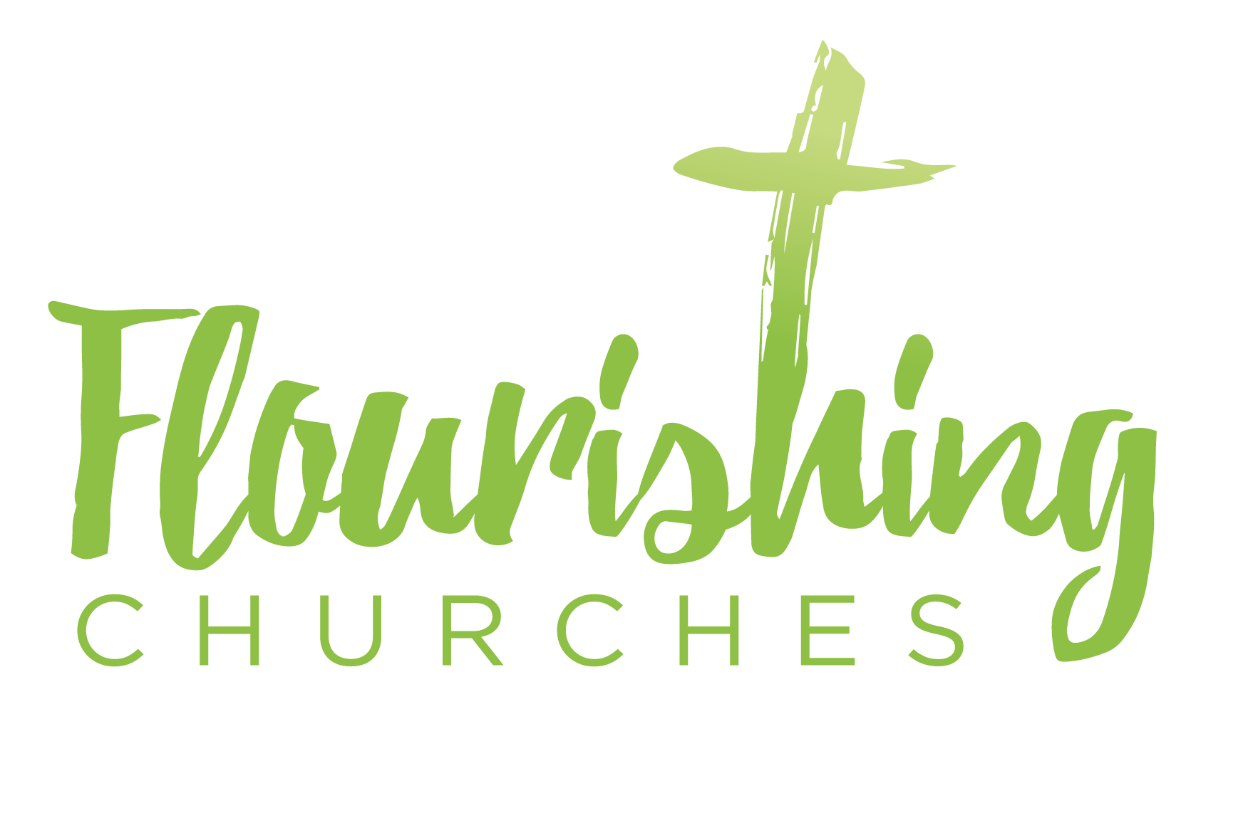

Low Sunday or Easter Two - 19th April 2020

How to use these prayers

Please work through the prayers at your own pace. It may take you thirty minutes it may only take five. If you are using this sheet online you may like to find some links to your favourite Hymns – You Tube is great for this.

A BRIEF INTRODUCTION TO LOW SUNDAY
Low Sunday is perhaps called this in contrast to the ‘high’ of the feast of Easter itself. It is still part of the Easter feast but is lower key in style and feel. In some places it is known as Thomas Sunday due to the Gospel reading of Thomas’ encounter with the risen Christ. However you want to name this day, maybe it is a day to consider your own faith and relationship with Jesus. Are you full, and coming down from the ‘high’ of last week, wanting something more ordinary and everyday? Are you like Thomas wanting to reach out and touch God? Are you experiencing doubts and fears? Are you missing other people and their physical presence in church and worship? Wherever we are or whatever we see this Sunday as, we worship now thanking God for a new day and we seek to encounter God truthfully and lay ourselves before him as he lay himself before Thomas.

Gathering Before God

Make sure you are sitting comfortably. Light a candle if you have one; any candle will do.

Breathe slowly and deeply.

I am in the presence of the Living God, Father, and of the Son, and of the Holy Spirit. Amen.

Prayer of the Day
Risen Christ, for whom no door is locked, no entrance barred:
open the doors of our hearts, that we may seek the good of others and walk the joyful road of sacrifice and peace, to the praise of God the Father. Amen.

Reflection
Breathe slowly and deeply.

Ask God to speak to you through the passage that you are about to read.

Bible Readings: Acts 2v14a, 22-32 and John 20 v19-end

Reflection:
I have to admit to always having a soft spot for Thomas; a rather sombre disciple, but also loyal. His universal reputation as a doubter always seems a little unfair. In John 11 v16 – he speaks with great faith of going with Jesus to Jerusalem, even if it means death, and he says this as they are about to embark on the journey to visit Mary, Martha and Lazarus, when Lazarus has died. This is a man of commitment and solidarity – he may not always understand (who does?) but he follows with loyalty and it appears a degree of stoicism. Even in John 14 v5, when after Jesus has washed their feet and commanded them to love one another, and told them that there is a place for each of them in the Father’s house ‘Lord, we do not know where you are going. How can we know the way?’ Thomas is consistent in his faith and in his need for clarity and surety. Maybe this is why I like him so much! Especially right now, when nothing feels very sure and where clarity and consistency are hard to come by. This virus has shaken everything – no more routines, predictability and ordinariness. Maybe like Thomas we are also saying – ‘How can we know the way?’
Maybe take a moment and think about Thomas’ questions – which is most like yours today? Maybe none, maybe all or maybe a combination? Are you ready to follow? Ready to question? Listening for God’s answer or stretching your hand out to touch God, needing and desperate for interaction and solidity? Something divine to lay your hand on – knowing that God knows and our scars are God’s scars too. God suffers with us; there is nowhere God has not been first.

The other reason I like Thomas is that he missed Easter too – he was not there on the first day of that first week when Jesus first appeared. His reason for being missing is lost to history – but it is clear he wasn’t there. Maybe he was lost in grief and aimlessly walking the streets of Jerusalem; so often in deep grief we find ourselves somewhere and don’t really know how we got there or why we did. Grief is disorientating. Or maybe he was being practical and had gone to get some food? Or maybe he was searching for Judas, seeking justice and understanding. We do not know; but it is wonderfully human to know that Thomas was not there.
Maybe we feel a bit like that at the moment – not ‘there’ not in church, or not ‘there’ anywhere other than virtually on a screen. Or maybe we’ve been furloughed or even laid off and are wondering about our identity with our employment removed? Or maybe our work has increased, and we have not had time to be fully present outside our jobs and tasks? Maybe the removal of our normal routines has made us feel less present, with less capacity to think deeply as survival mode kicks in. Maybe we are grieving, maybe for a loved one, maybe for all that we are missing; trips, events, holidays, gatherings, work, meetings, school?

Thomas was not there and so Jesus, ever faithful, returns the following week. And Thomas wants to touch him – feel his presence with his hands. Maybe we too feel like that – wanting to hold the bread and drink the wine, tasting, touching, smelling, savouring all that it is. Having to be patient, yet yearning.

And so the encounter finally happens – Thomas meets the risen Jesus. Jesus first utters his peace, and then invites Thomas to touch him, and interestingly we don’t know whether he does or not. But Thomas does answer, ‘My Lord and my God!’ He recognises Jesus and declares his faith. Thomas amidst his doubts and confusion and grief declares for the first time that Jesus is God.

I wonder when that was for you? If you ever have? Maybe today is the day to declare your faith anew or declare it for the first time.

Thomas with all his human nature, his doubts, his questions, his loyalty and his determination offers us inspiration. We can question. We can doubt. We can mourn. We can reach out and touch. We can have faith.

When God shared his peace and his breath of Spirit the disciples believed. Thomas only believed when he was close enough to touch, and be breathed on by God’s own breath.

We too pray for the Spirit of God to be in us and around us; guiding us onwards and giving us breath to declare for ourselves ‘My Lord and my God’.

Creative Prayer activity
Breathe slowly and quietly – fill your lungs up, and exhale slowly and purposefully. With each inhale imagine the spirit of God filling you with love and light and life. And breathe out the doubt and darkness. Reach your hands outwards, expectant, ready to receive. Does this several times, as many as feels right.

My Lord and my God, when I doubt forgive me. When I am not present call me back into your presence. When I don’t understand, give me meaning and purpose. When I am frightened, hold me by my right hand. Lord Jesus as you were faithful to Thomas, be faithful to me and all whom I love. Let me treasure all that I touch today, knowing all life is a gift from you. Amen.

A prayer concerning the Coronavirus

Keep us, good Lord,
under the shadow of your mercy.
Sustain and support the anxious,
be with those who care for the sick,
and lift up all who are brought low;
that we may find comfort
knowing that nothing can separate us from your love
in Christ Jesus our Lord. Amen From the Church of England website

An act of spiritual Communion
My Jesus,
I believe that You
are present in the Most Holy Sacrament.
I love You above all things,
and I desire to receive You into my soul.
Since I cannot at this moment
receive You sacramentally,
come at least spiritually into my heart. I embrace You as if You were already there and unite myself wholly to You. Never permit me to be separated from You. Amen.

Taken from https://www.ewtn.com/catholicism/devotions/act-of-spiritual-communion-339

The Lord’s Prayer

Our Father, who art in heaven, hallowed be thy name;
thy kingdom come; thy will be done; on earth as it is in heaven. Give us this day our daily bread. And forgive us our trespasses, as we forgive those who trespass against us. And lead us not into temptation; but deliver us from evil. For thine is the kingdom, the power and the glory, for ever and ever. Amen.

With the power that raised Jesus from the dead at work within you,
go in peace to love and serve the Lord. Alleluia, alleluia.
In the name of Christ. Amen. Alleluia, alleluia.

